**Jenkins Practice Lab**

**Tasks**

1. **Working with Jenkins Builds and Plugins………………………………………02**

## Test Automation in Jenkins…………………………………………………………..10

## Application Deployment in Jenkins……………………………………………….13

## Pipeline_job………………………………………………………………………………….19

**Percipio Jenkins Practice Lab execution steps**

**Repository:** https://github.com/Devopstraininglab/SpringBootCurdRestFull.git

Type Jenkins URL “http://localhost:8080/” in the address bar

Type “admin” in the User text box

Type “Passw0rd” in the Password text box

Click “log in”

**Note:** Sometimes special character behaving differently in Virtual Machine. So, first write down password in txt file and use the same.

**Tasks**

1. **Working with Jenkins Builds and Plugins**

Click on “New Item”: To create new job

Mention any project name: ***SpringBootMavenApp***

Select “***Freestyle project***”

Click on “***OK***” button.

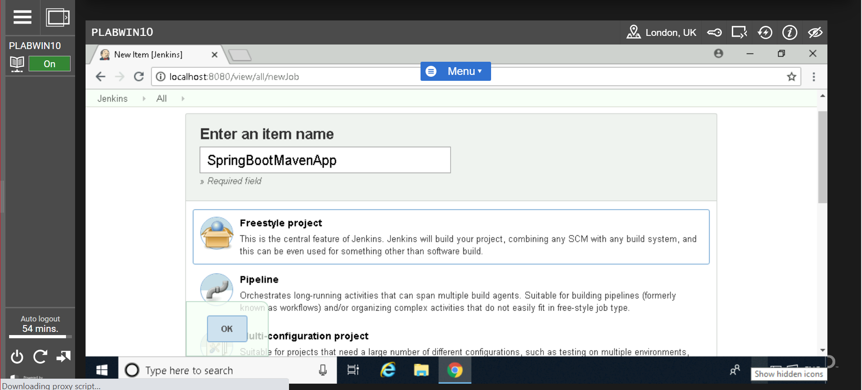

**Click on “General “tab**

In “***Description***”: Enter Project Description: ***SpringBootMavenApp***

Select “***Discard old builds***” and enter below details:

Strategy: Log rotation

Day to keep builds: 10

Max # of builds to keep: 10

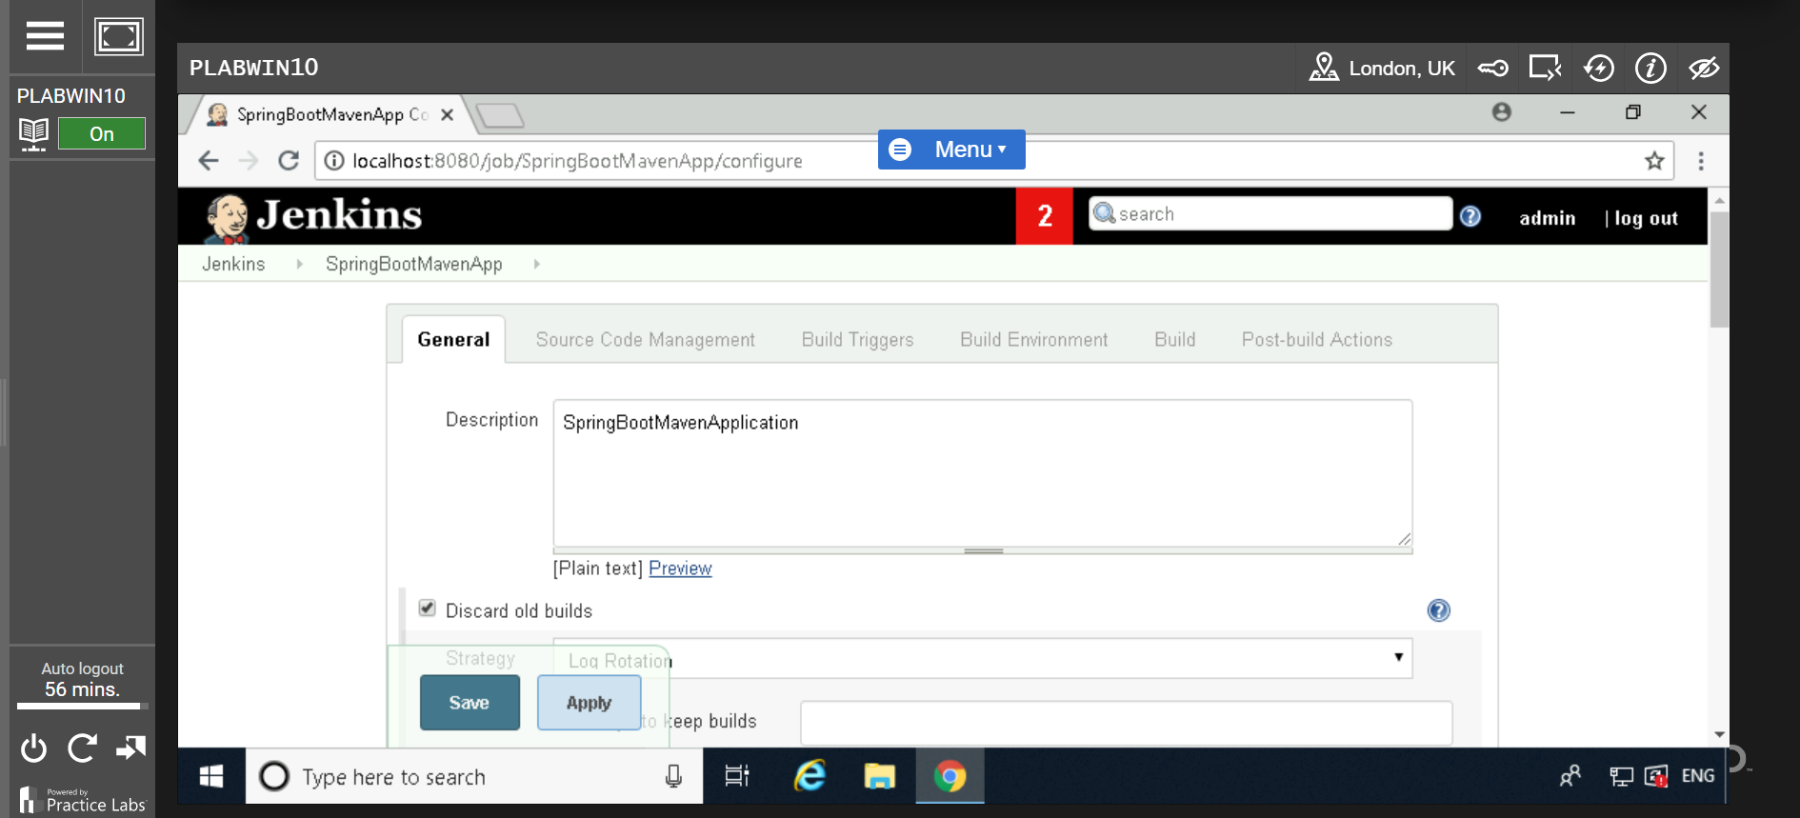

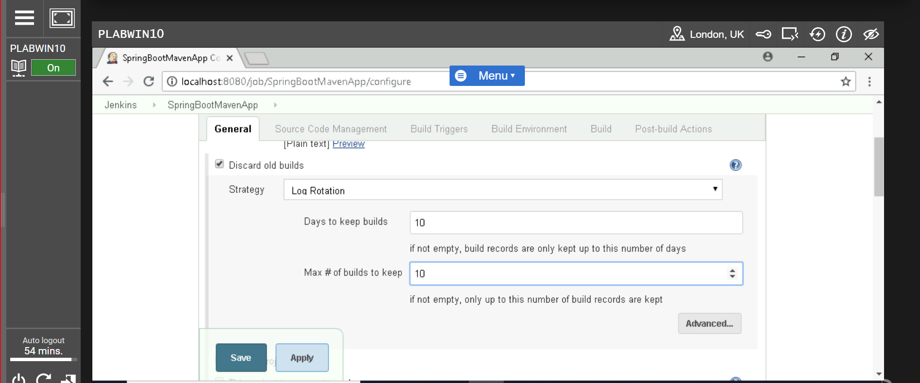

Select “***Execute concurrent build if necessary***”

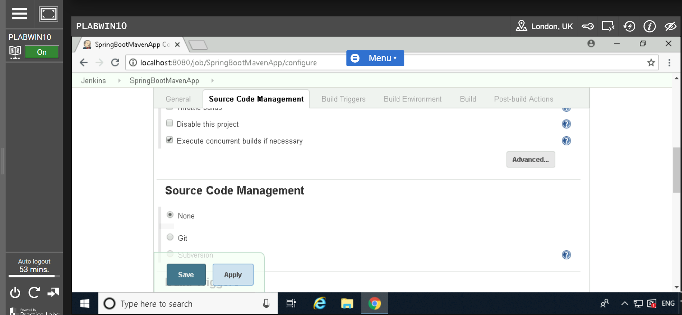

Select “***GitHub project***” and enter Project URL:

https://github.com/Devopstraininglab/SpringBootCurdRestFull.git

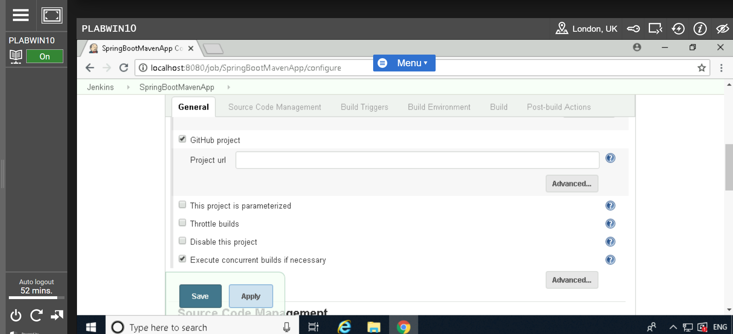

**Click on “Source code management” Tab**

Select “***Git***”

Enter repository URL: https://github.com/Devopstraininglab/SpringBootCurdRestFull.git

Credentials: Above repository is public so we can ignore credential and leave as “none”.

Branches to build: */master

Repository browser: (Auto)

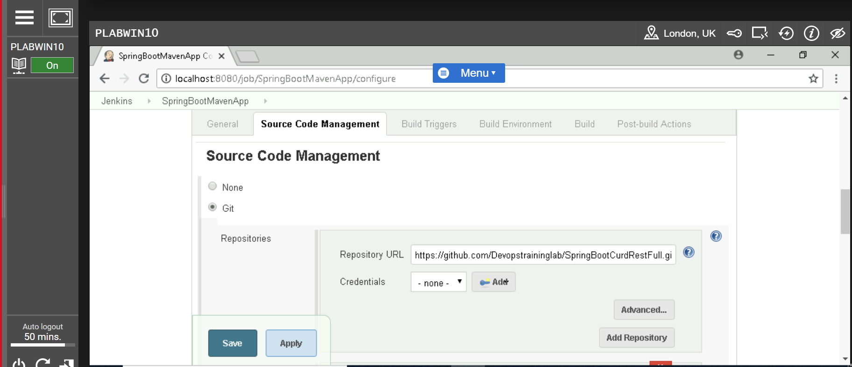

**Click on “Build Triggers” Tab**

Select “***Poll SCM***”

Schedule: ***H/15 * * * \****

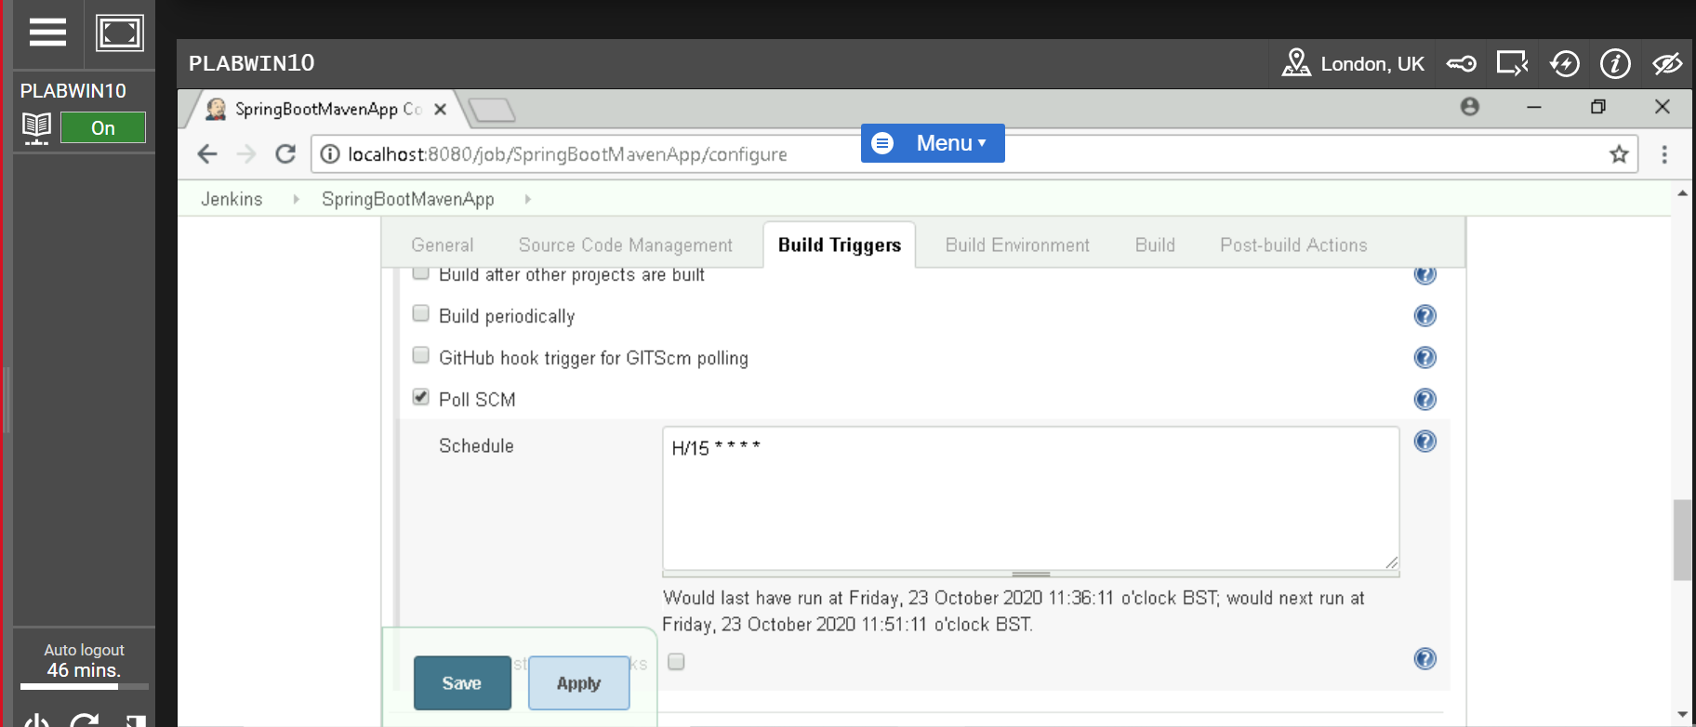

Note: Polling it every 15 mins for code changes

**Poll SCM**: Configure Jenkins to poll the SCM for ant pushes or commits and then trigger the jobs.

**Click on “Build Environment” Tab**

Select “***Delete workspace before build start***”

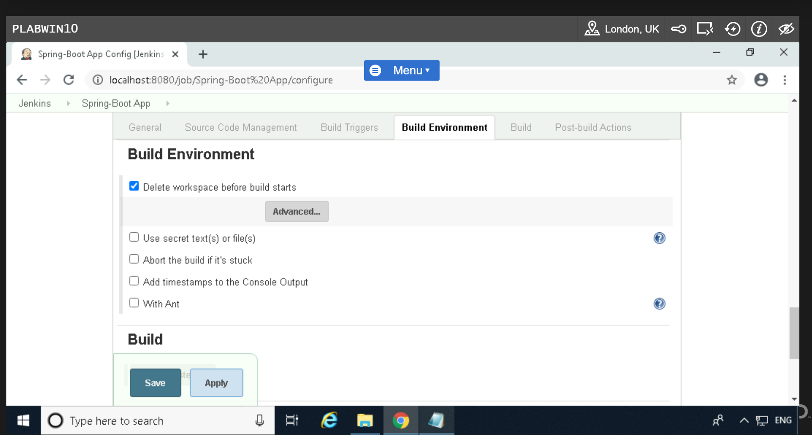

**Click on “Build” Tab**

Click on “***Add build step***” button and select “***Invoke top level maven target***”

In Maven versions: select “***maven install***”

In Goals: use “***clean verify***” command

Now finally click on “***Save***” button

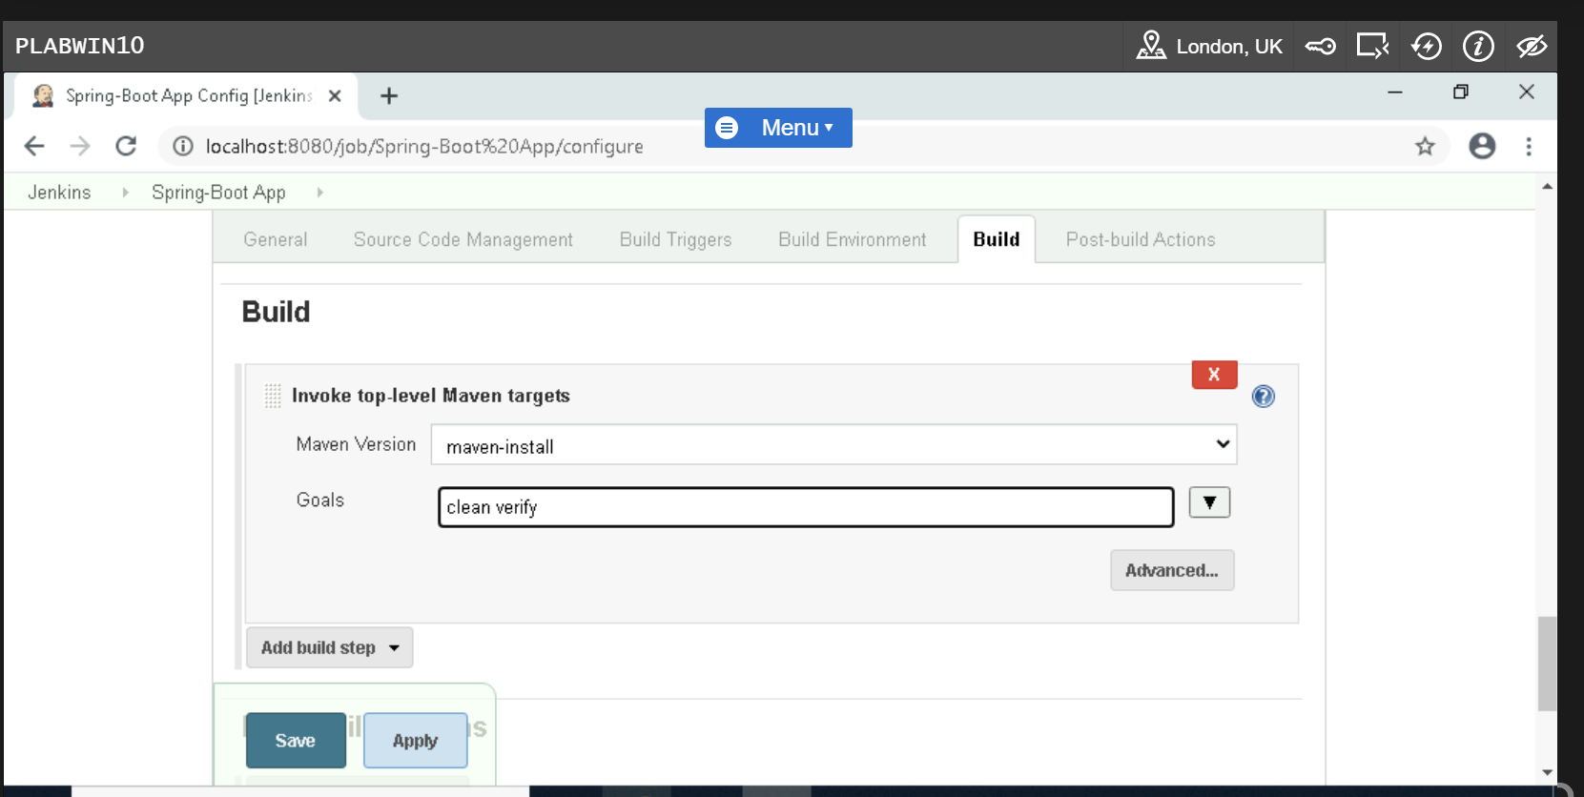

Go Back to Jenkins Dashboard

Click on project “***SpringBootMavenApp***”

Now click on “***Build Now***” from menu bar

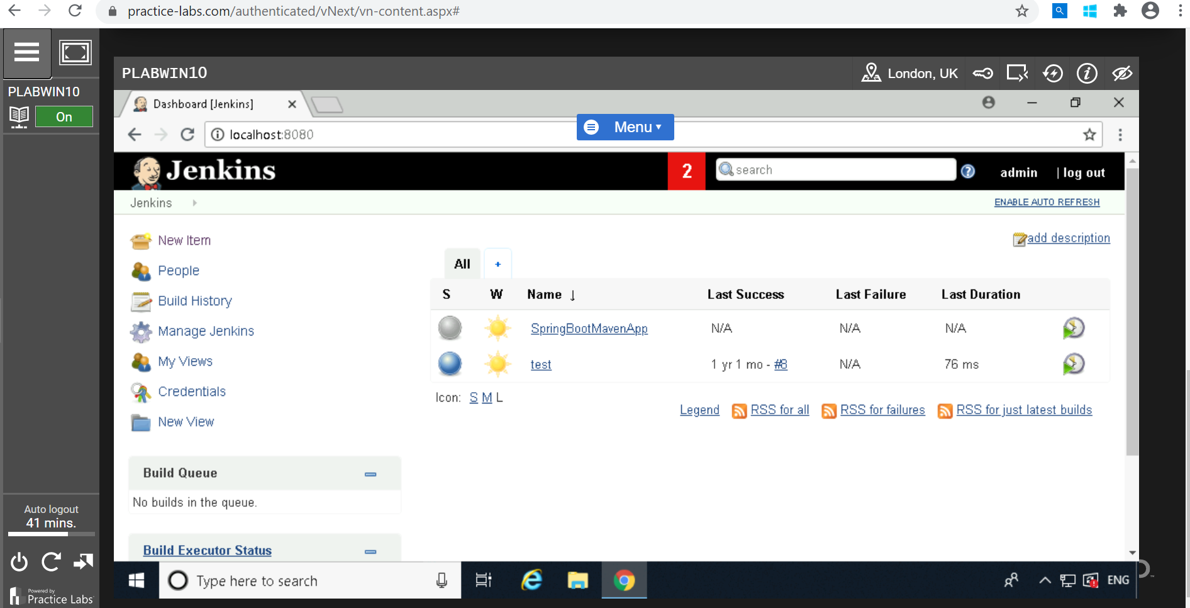

Click on “***Workspace***” from menu bar

Click on “***target***”: Now we can see war files.

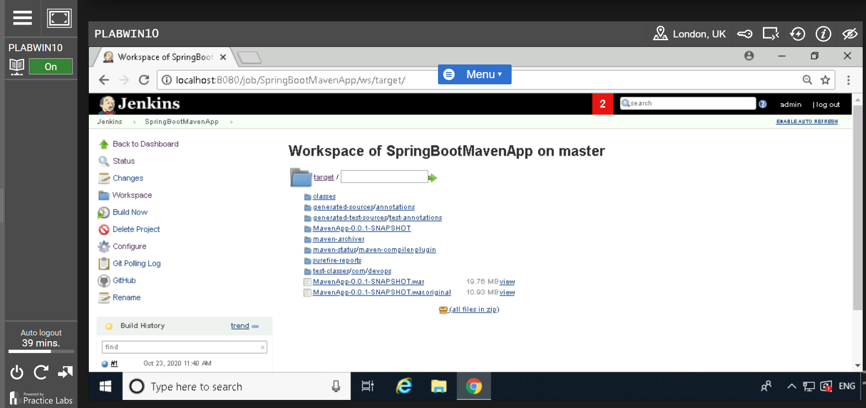

Go back to “***Jenkins***” dashboard and take cursor to triangle symbol of Jenkins Button

After that take cursor to “***Manage Jenkins***” to “***Manage plugins***”

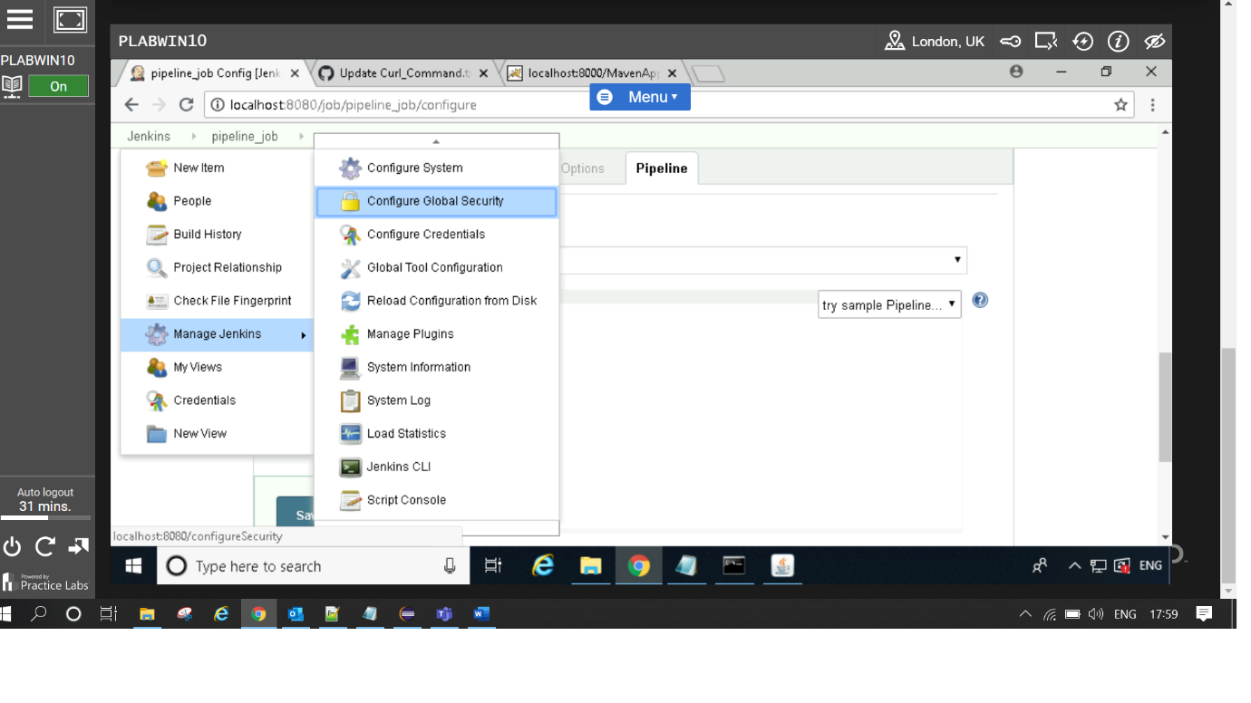

Click on “***Available***” tab

Search/Filter “***Build monitor view***”

Select “***Build Monitor View***” and click on “***Download now and restart Jenkins***”.

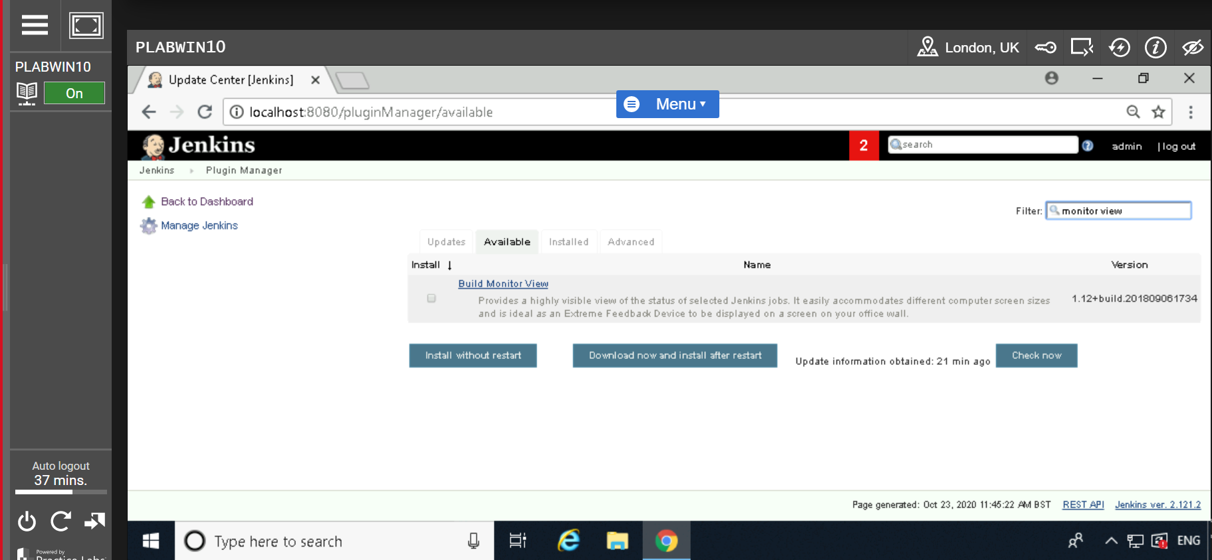

Click on “***Restart Jenkins when installation is complete and no jobs are running***.”

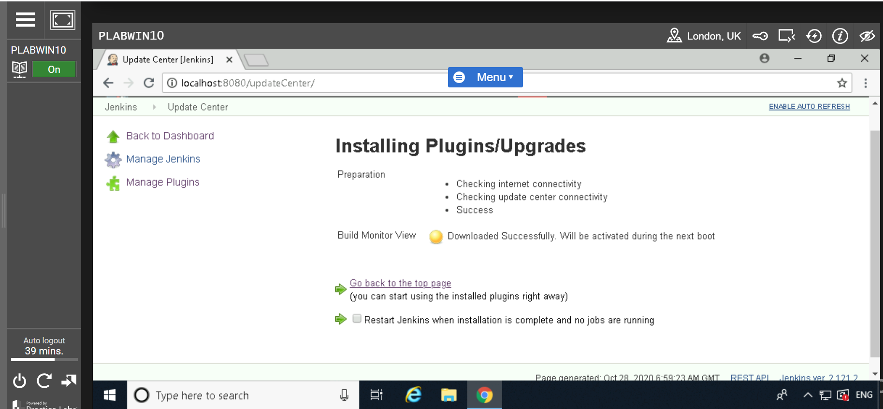

Go back to ***Jenkins*** menu

Click on “+” tab parallel to “***All*** ” tab

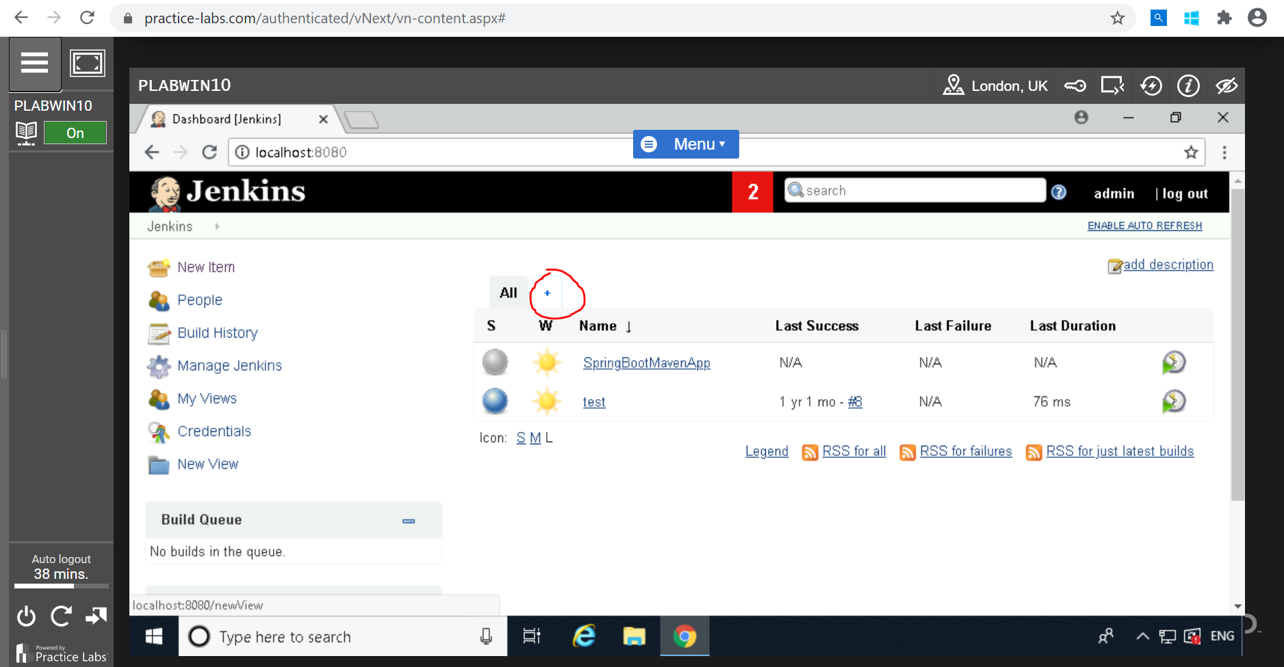

Write view name: Any name “***SpringBootMavenApp Monitor***”

Select ***Build monitor view***

Click on “***OK***”

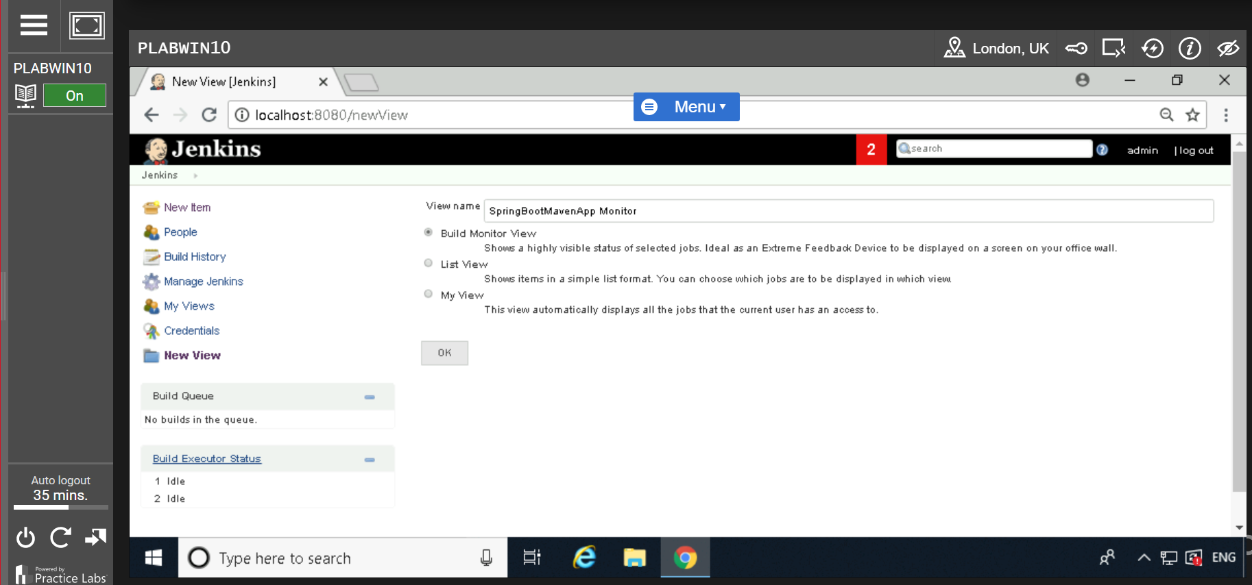

Scroll down to “***Job filters***” section

Select projects under “***Jobs***”: “***SpringBootMavenApp***” and “***test***”

Click on “***OK***”

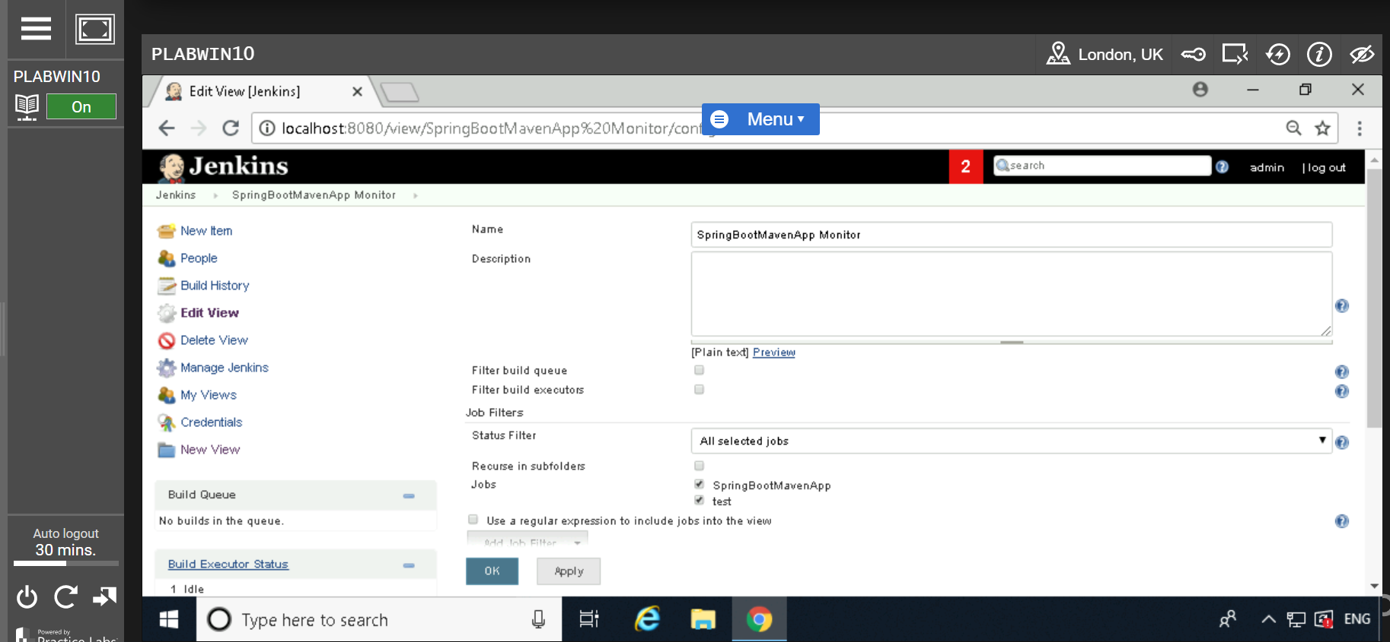

Note: Build monitor view: It is graphical representation of failing/passing job after build.

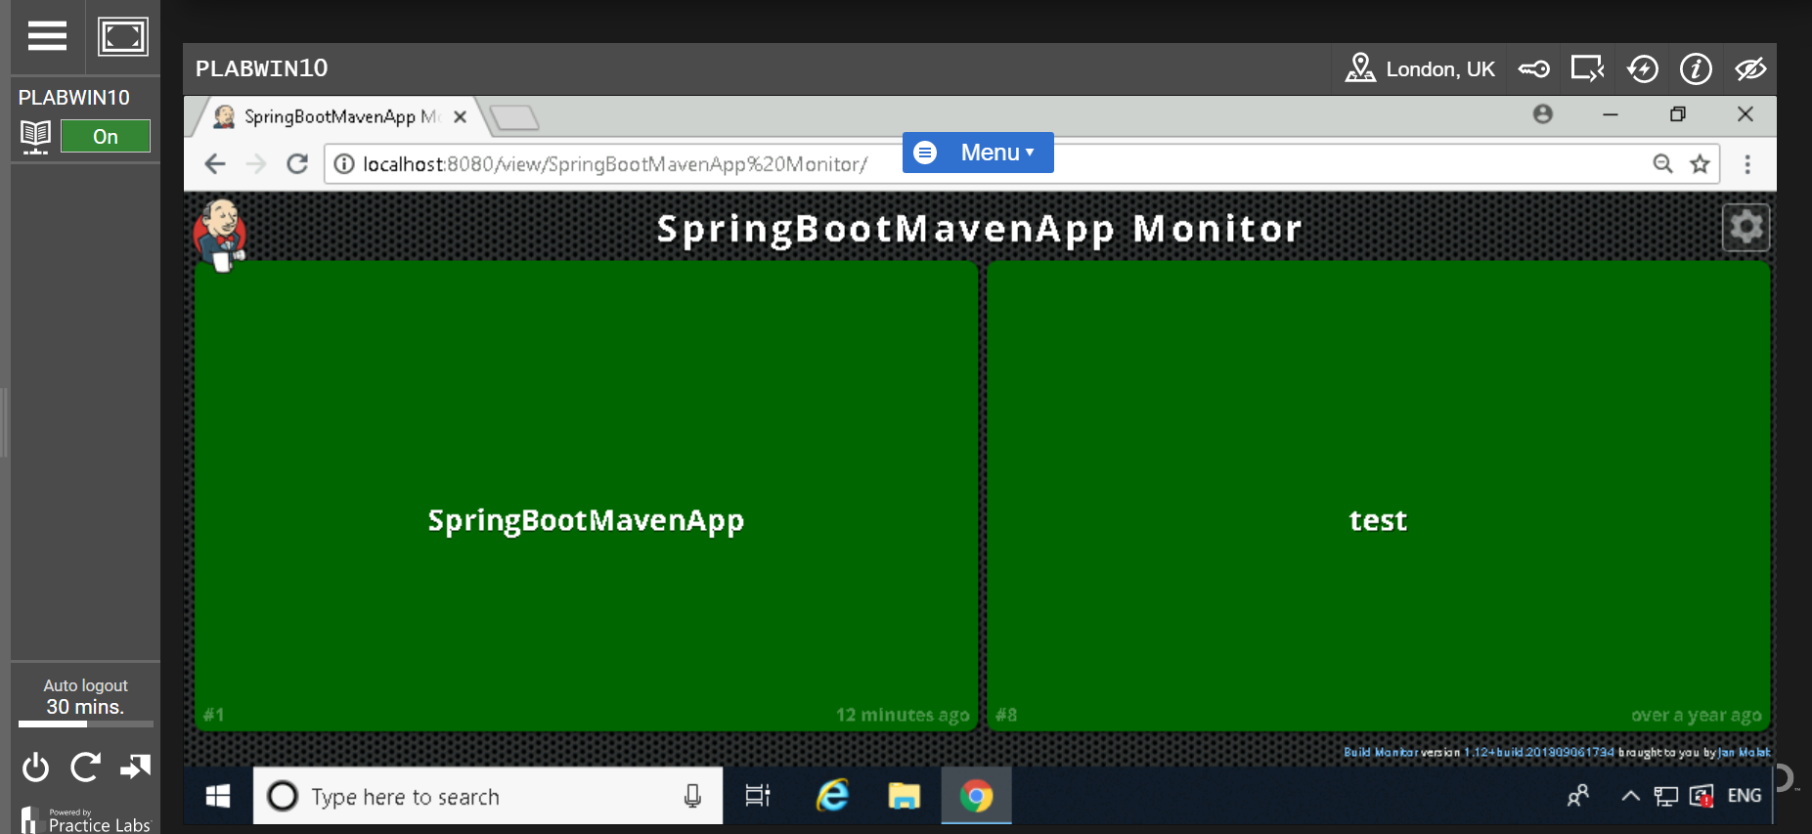

**--------------------------------------------------------------------------------------------------------------------------------------**

## Test Automation in Jenkins

Go back to ***Jenkins Dashboard***

Click on “***Manage Jenkins***”

Click on “***Manage plugin***”

Click on “***Available***” tab

Search “***TestNG Result***” plugin

### Select and Click on Click on “*Download now and install after restart*”

### 

Click on “***Restart Jenkins when installation is complete and no jobs are running***.”

### 

### Go to Jenkins dashboard

### Click on “*SpringBootMavenApp”*

### Click on “*Configure*”

### Click on ‘*Build’* tab

Click on “***Add built setup***” and select “***Invoke top level maven targets***”

Enter Maven version: “***maven install***”

Goals: “***clean test***”

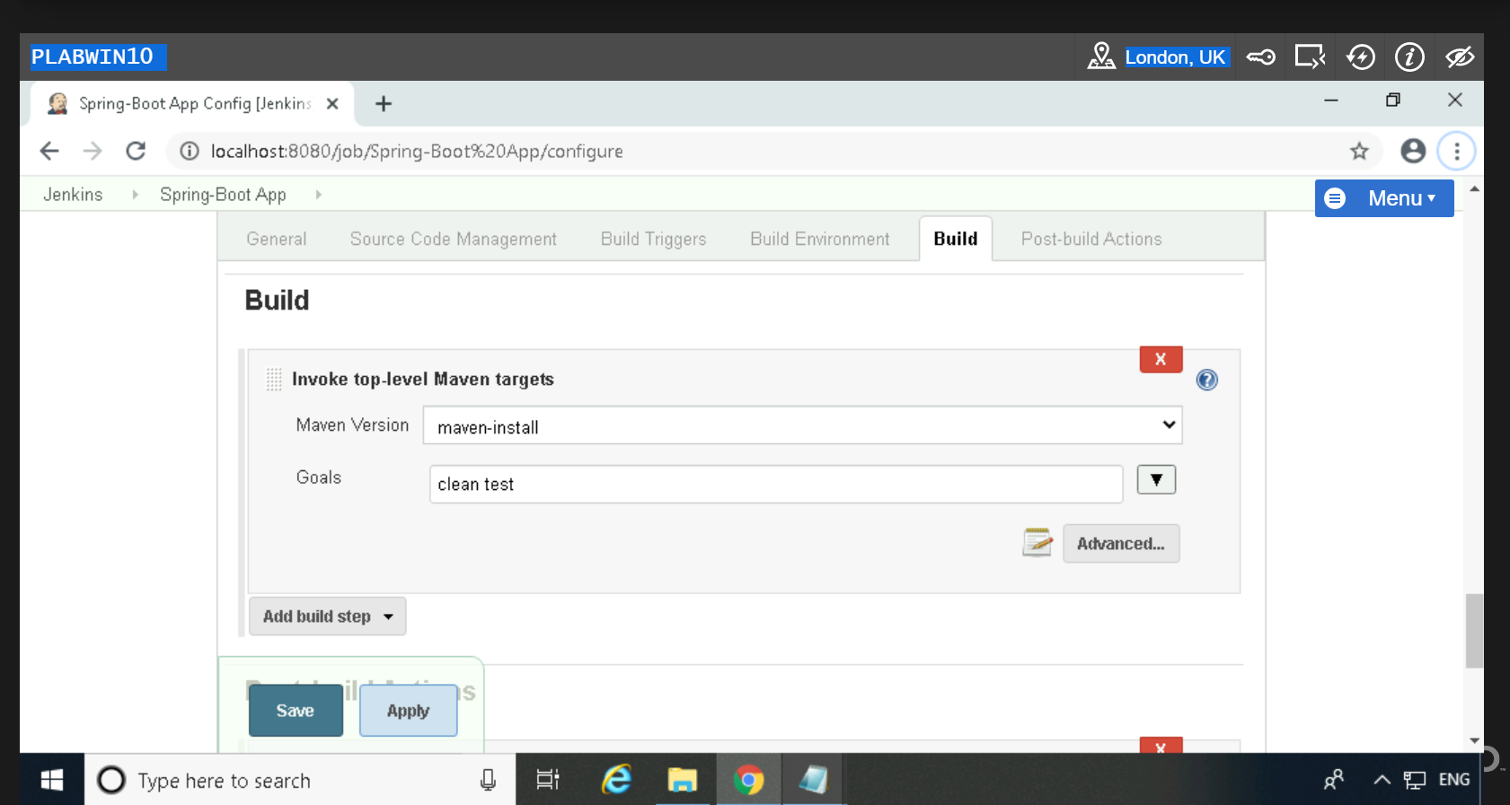

Click on “***Post-build Action***”

Click on “***Add post build Action***”

Select “***Archive the artifacts***”

File to archive: **

Select from “***Publish TestNG Results***” from “***Add post build action***”

In TestNG XML report pattern enter: ***\*\*/testing-results.xml***

Click on ‘Save’

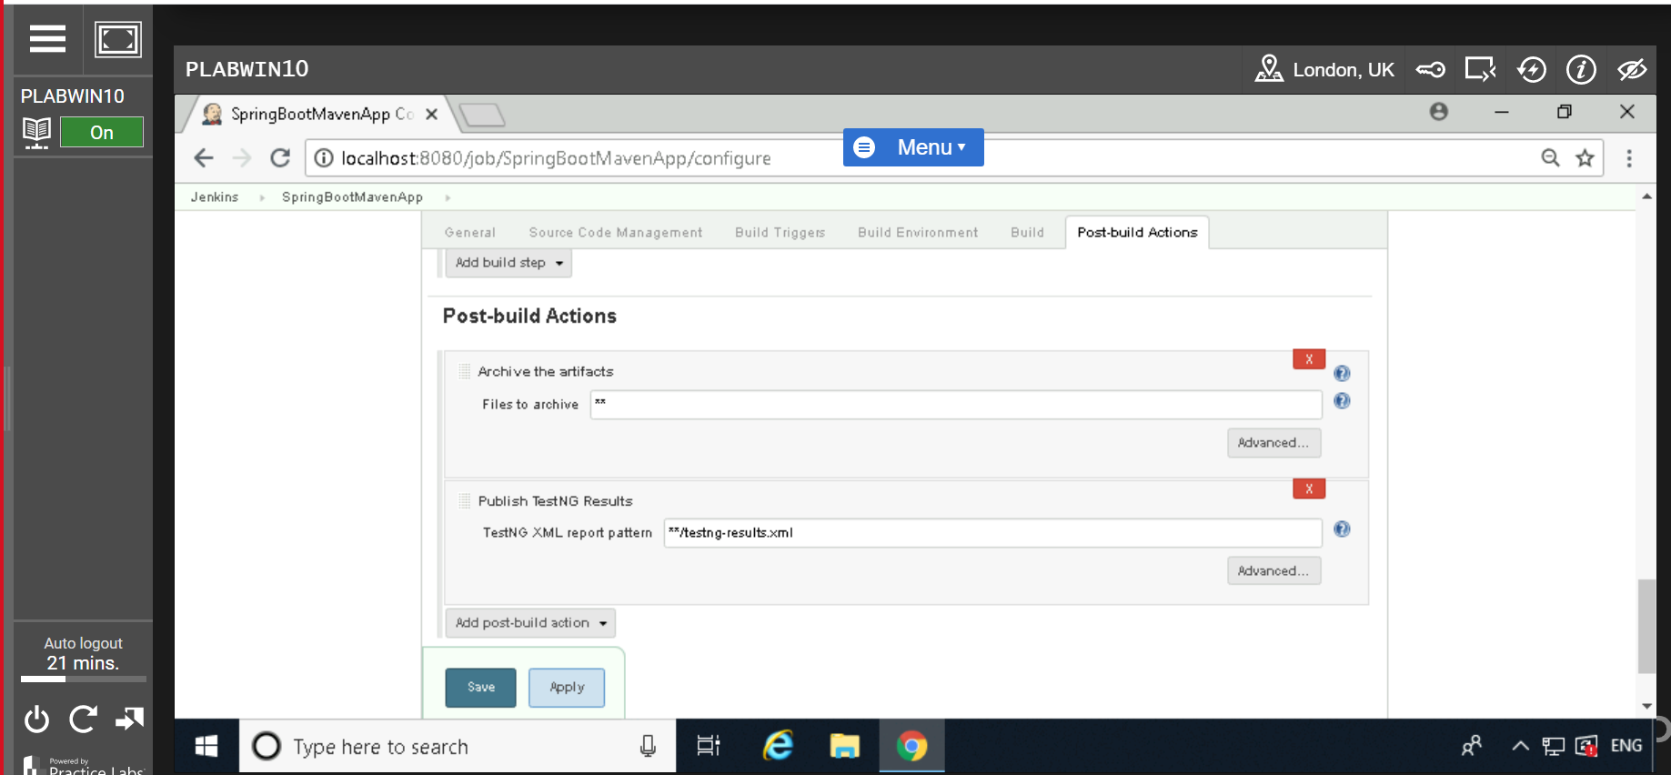

Click “***Build now***”

See the console to know more about build success or Refresh the browser.

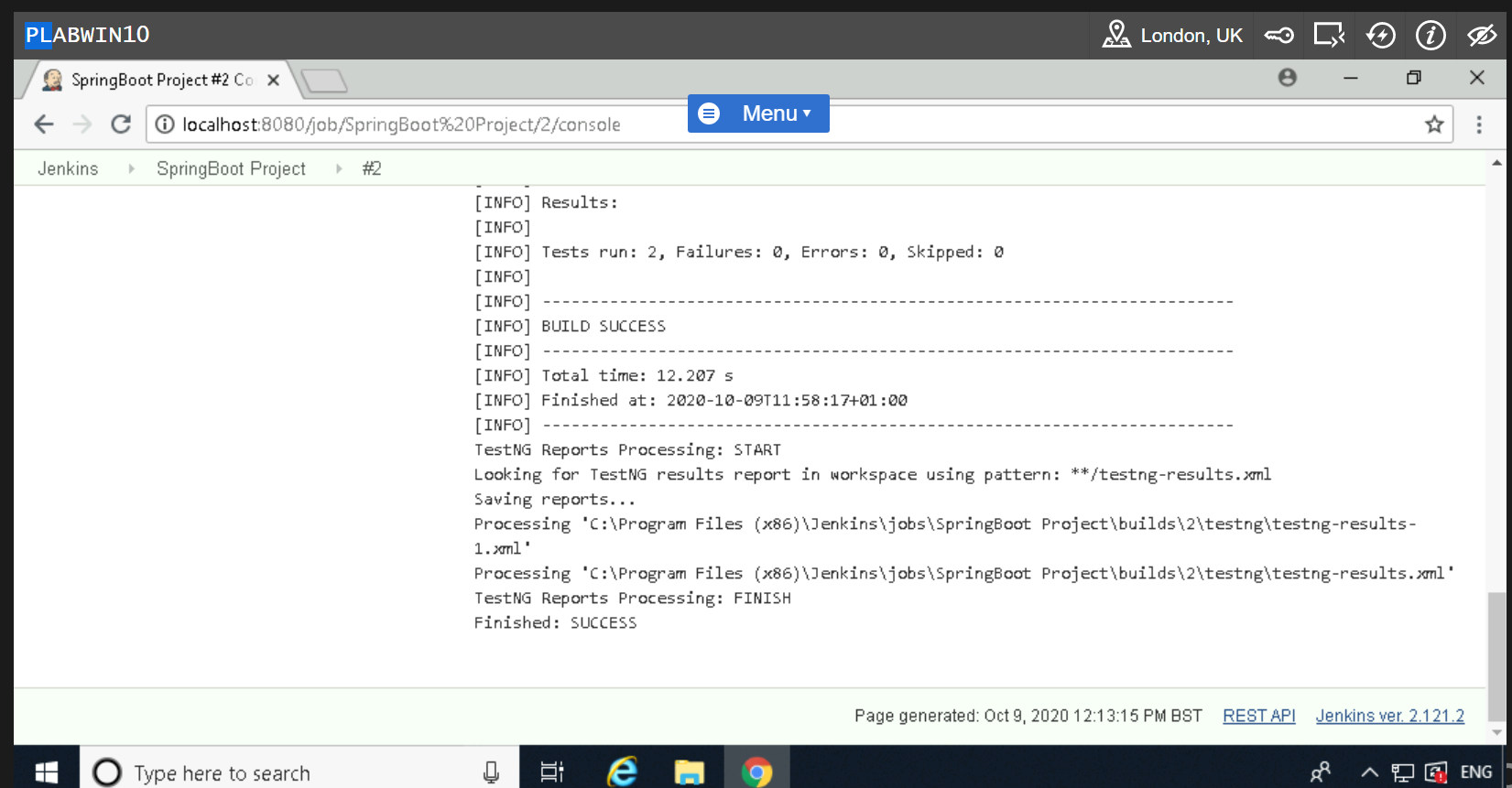

Click on “***TestNG result***” from menu tab to see the pass/fail test case

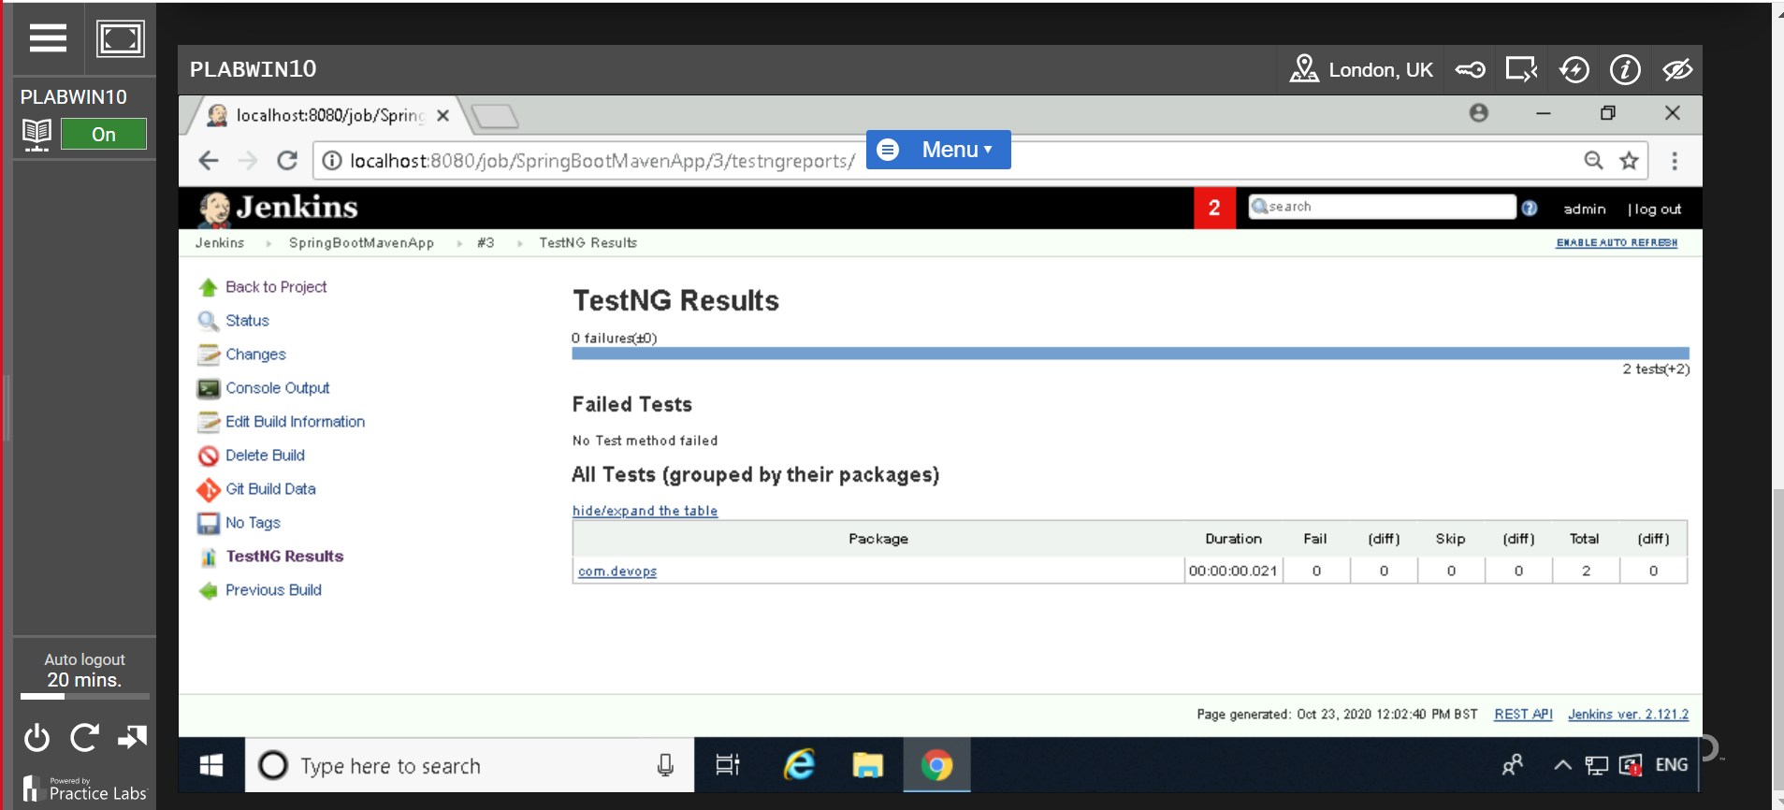

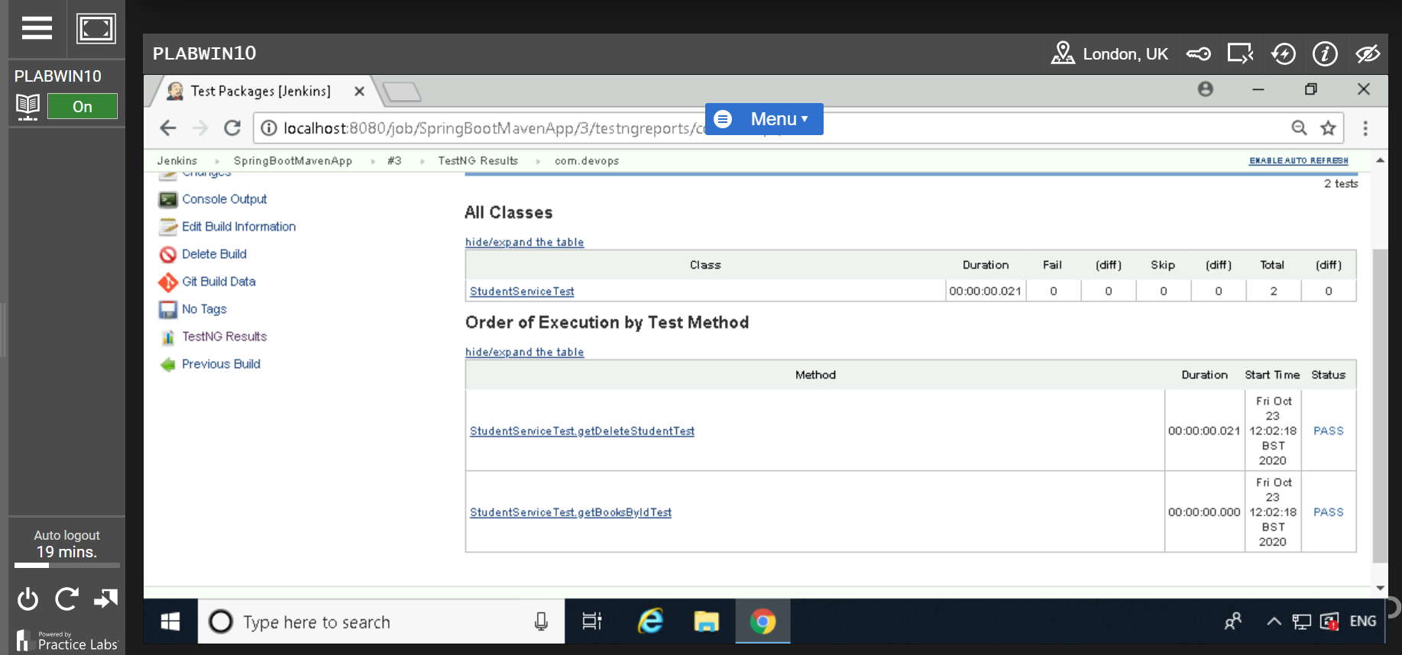

-----------------------------------------------------------------------------------------------------------------------------------

## 3. Application Deployment in Jenkins

Add the 'Deploy WAR/EAR to a container Jenkins' plugin

### Go Back in Jenkins Dashboard

### Select “*Manage Jenkins*” from menu bar

### Click on “*Manage plugin*”

### From “*Available”* tab Search “*Deploy to container*”

### Select Click on “*Download now and install after restart*”

### 

Click on “***Restart Jenkins when installation is complete and no jobs are running***.”

### 

Go Back in Jenkins, go to your job/**SpringBootMavenApp** and select “***Configure***”.

Click on “***Build***” tab and enter below details

Maven Version: ***maven-install***

Goals: ***clean install***

Click on “***Save***”

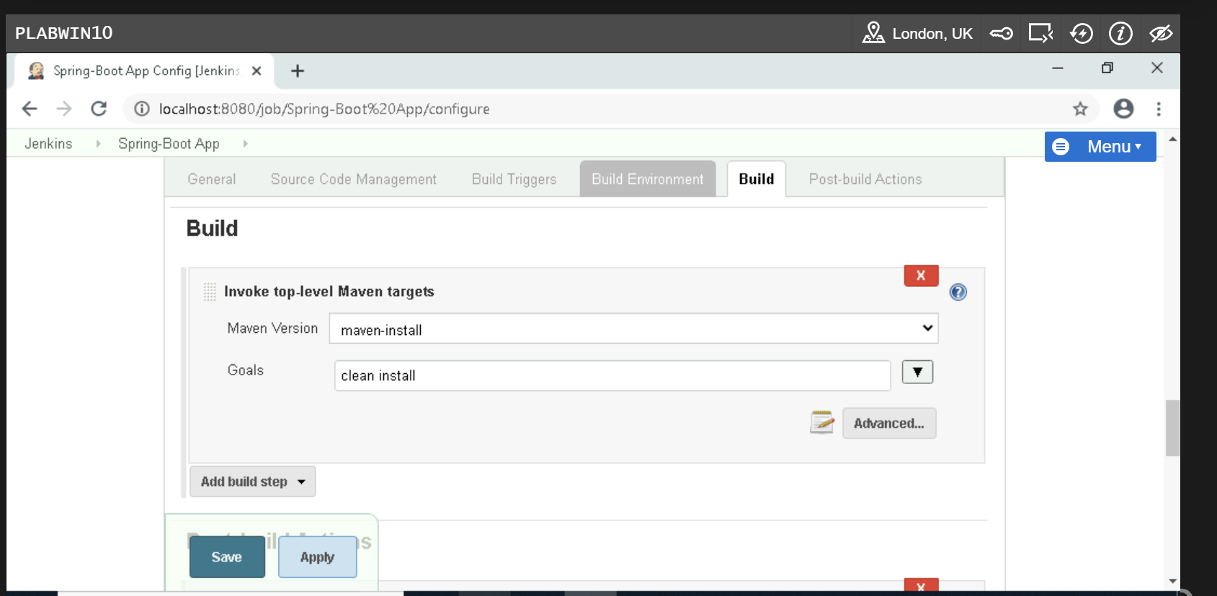

**Before going to “Post-build Actions” need to verify 3 steps:**

1. Make sure C:\Program Files\Apache Software Foundation\Tomcat 8.5 folder has all permission.

Right click on Tomcat 8.5 --select ‘***Properties’*** after that click on ‘***Security’*** tab and click on ‘***Edit’*** after that allow all permission to ‘***User(PLABWIN10\users)***’.

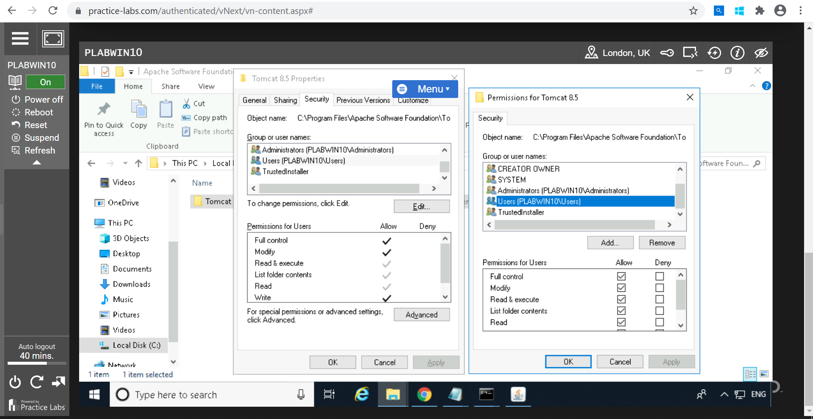

1. Add below line to ***tomcat-users.xml*** file under C:\Program Files\Apache Software Foundation\Tomcat 8.5\conf

<tomcat-users>

<role rolename="manager-gui"/>

<role rolename="manager-script"/>

<role rolename="manager-jmx"/>

<role rolename="manager-status"/>

<role rolename="admin-gui"/>

<role rolename="admin-script"/>

<user username="root" password="root" roles="manager-gui,manager-script,manager-jmx,manager-status,admin-gui,admin-script"/>

</tomcat-users>

1. Go to C:\Program Files\Apache Software Foundation\Tomcat 8.5\bin and type cmd on URL to set path for JAVA_HOME.

set JAVA_HOME=C:\Program Files\Java\jdk1.8.0_181

set PATH=%JAVA_HOME%\bin;%PATH%

After that run ‘ ***shutdown.bat’*** and ‘***start.bat’*** command and cross check <http://localhost:8000/> is working properly or not.

Once below screen will appear it means its running successfully.

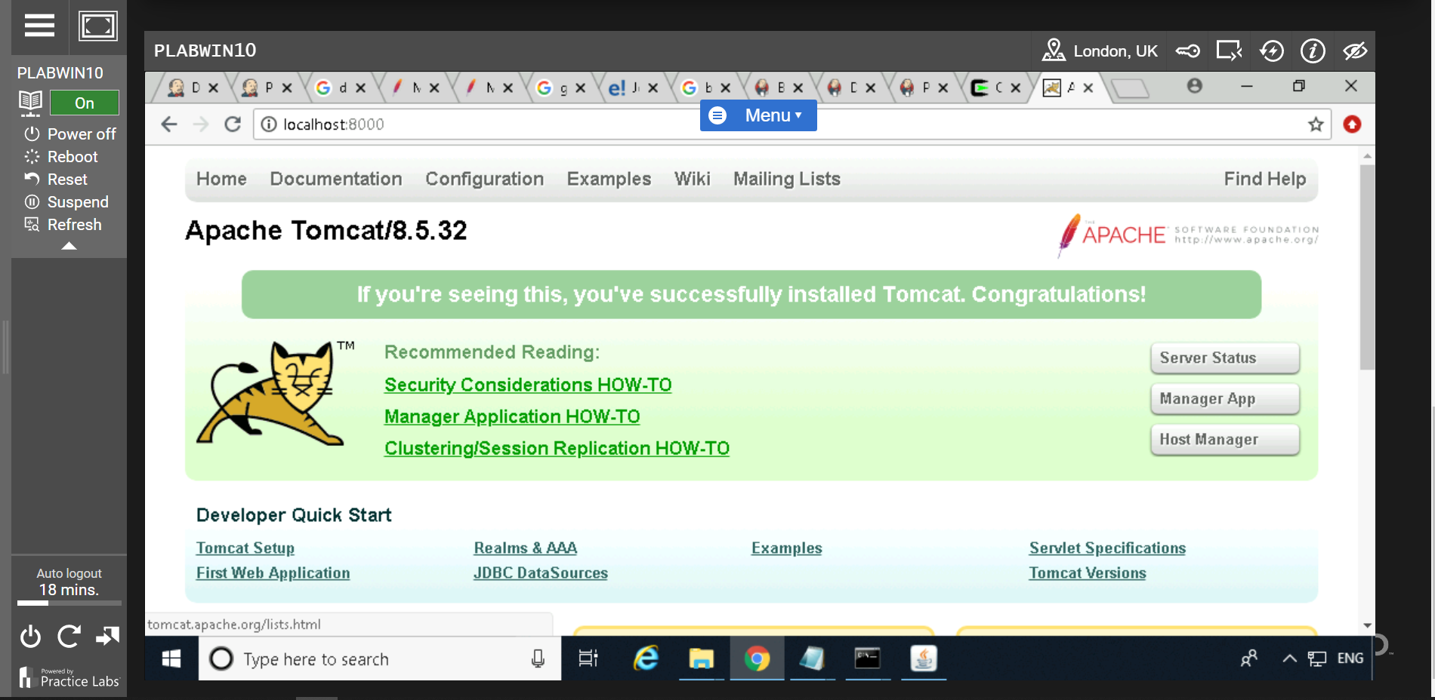

Click on ‘***Manager App’*** and enter Username: ***root*** and Password: ***root*** which is followed in step 2.

If below screen will appear it means Tomcat configuration is successfully connected.

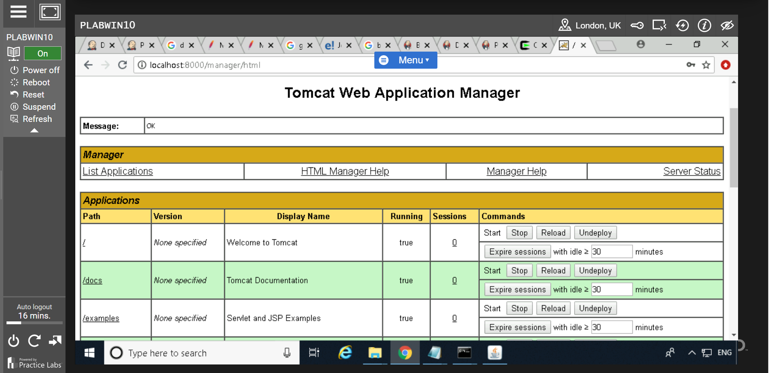

Go to Jenkins and navigate to **“Configure”** and **“Post-build Actions”** tab**.**

**Click on “Add Post build Action”**

Select the option “***Deploy war/ear to a container***” from the “***Add post-build action***” from dropdown button.

For WAR/EAR files you can use: **/*.war

Enter Context path: SpringBootCurdRestFull (Any name—folder will extract with same name under tomcat8.5 –webapp with war file.

Select containers from ‘***Add container button’***

***Select: Tomcat 8.x Remote***

Enter credentials: ***root***, Password: ***root***

Click on “***Add***”

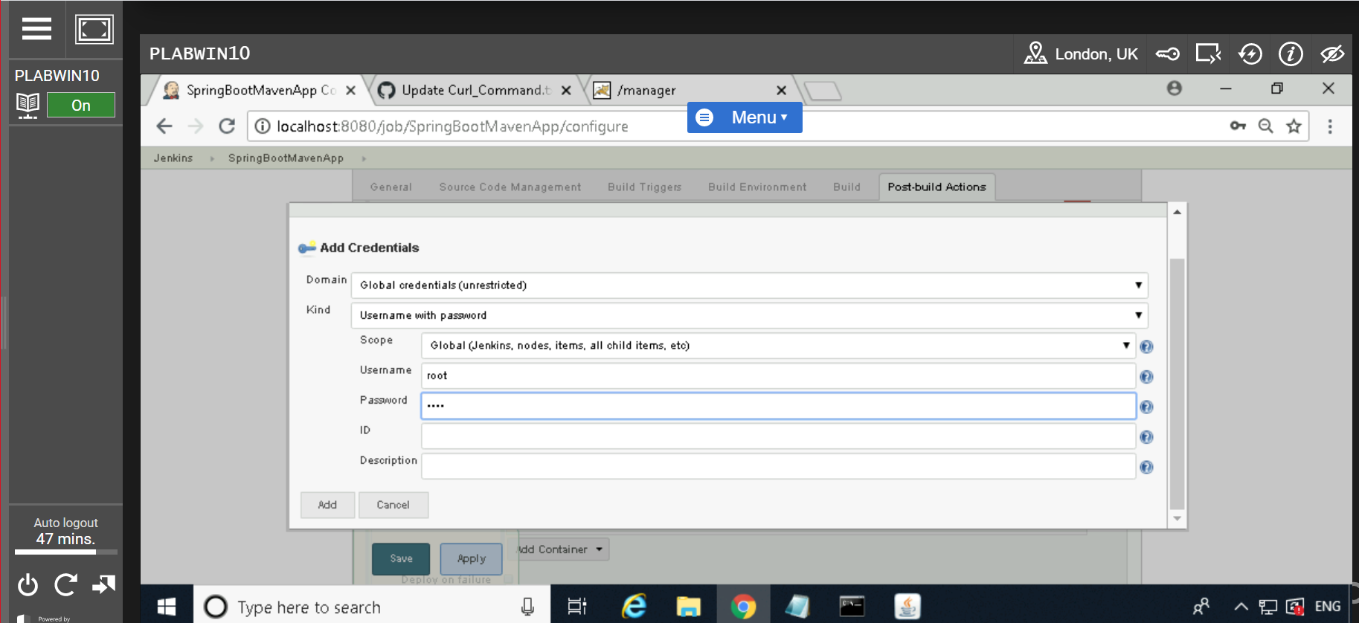

Select Credentials: Root/****

Above username and password must be match in below location file

tomcat-users.xml file under C:\Program Files\Apache Software Foundation\Tomcat 8.5\conf

which is followed in step 2.

Enter Tomcat URL: “http://localhost:8000/”

Click on ‘***Save’*** button

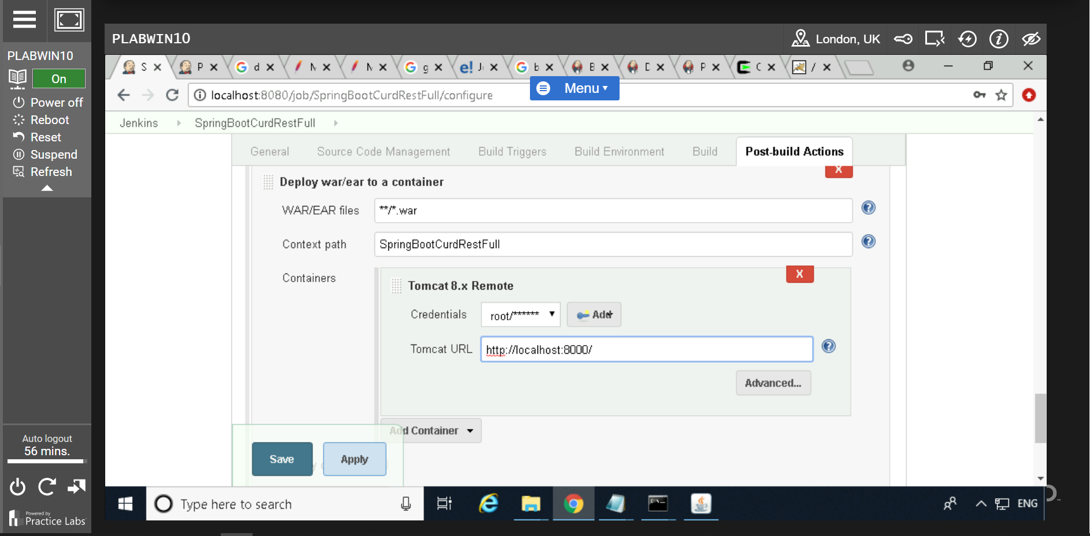

Click on ‘***Build now’***

Now we can see SpringBootCurdRestFull folder and .war file created under below location

Go to Tomcat directory= C:\Program Files\Apache Software Foundation\Tomcat 8.5\webapps

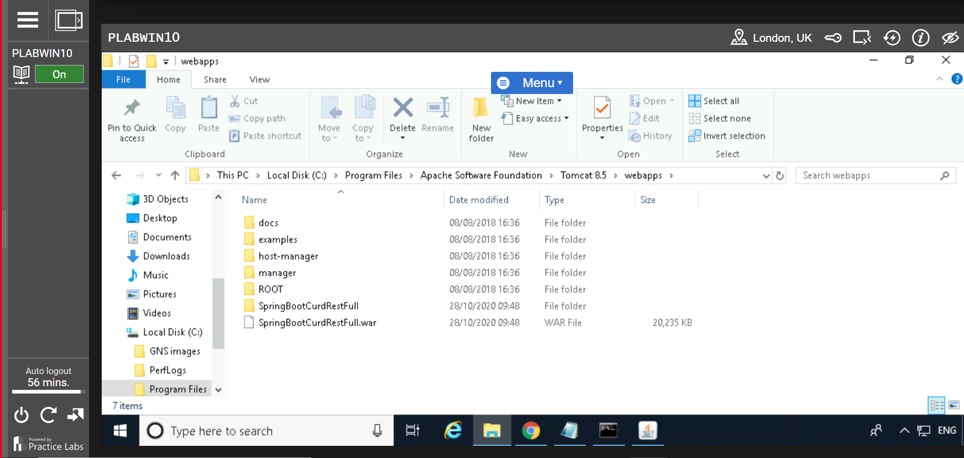

Download and install ***Postman plugin*** for chrome in virtual machine.

Launch Postman and Use below post URL with given body--raw

{​​​​​​​​"rollNo": 10, "name":"Arun", "totalMarks":5000}

URL: <http://localhost:8000/SpringBootCurdRestFull/api/student/>

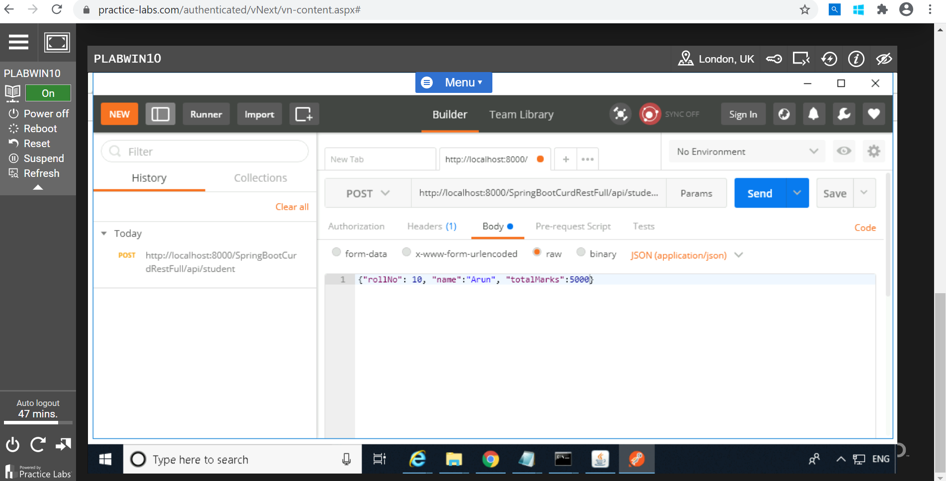

Get URL: <http://localhost:8000/SpringBootCurdRestFull/api/student/10>

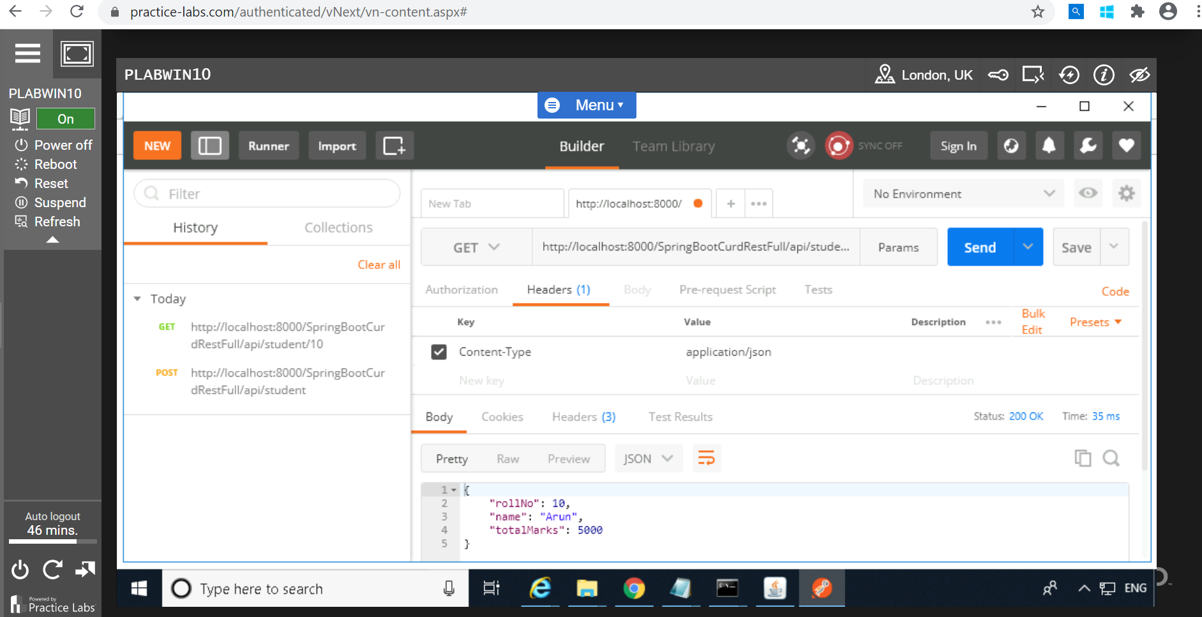

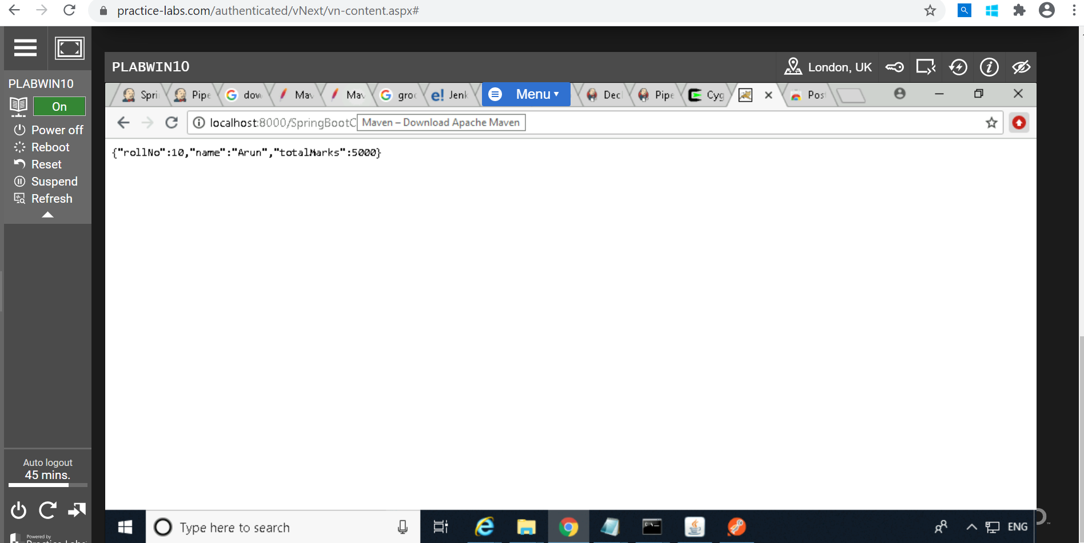

--------------------------------------------------------------------------------------------------------------------------------------

## Pipeline_job

Go to ***Jenkins***

Click on “***New Item***”

Enter an Item name: pipeline_job

Select “***Pipeline***”

Click on “***OK***”

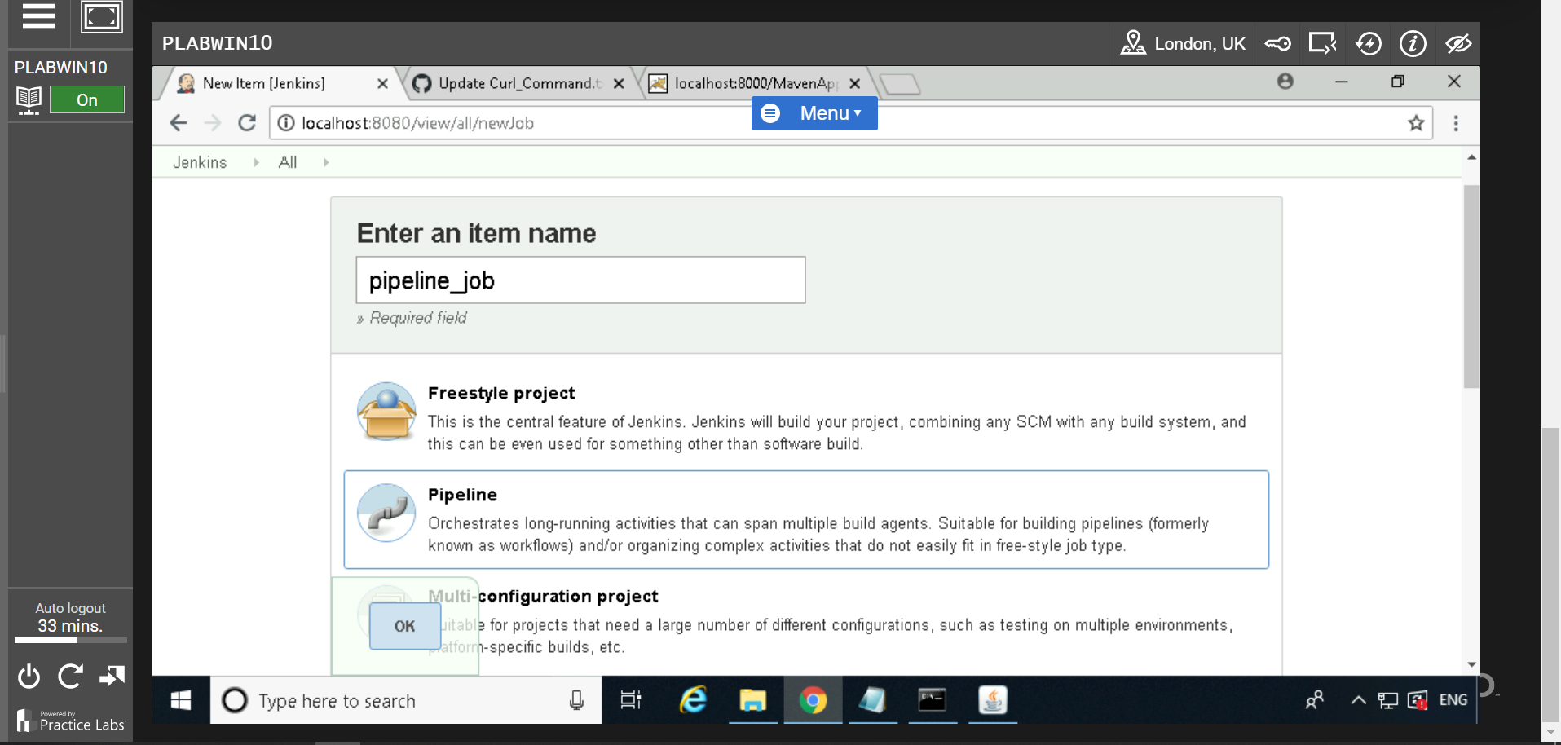

Go back to Jenkins dashboard and take cursor to triangle symbol of Jenkins Button

After that take cursor to “***Manage Jenkins***” to “***Global tool configuration***”



Enter below parameter value “***Maven Configuration***” as per below screen.

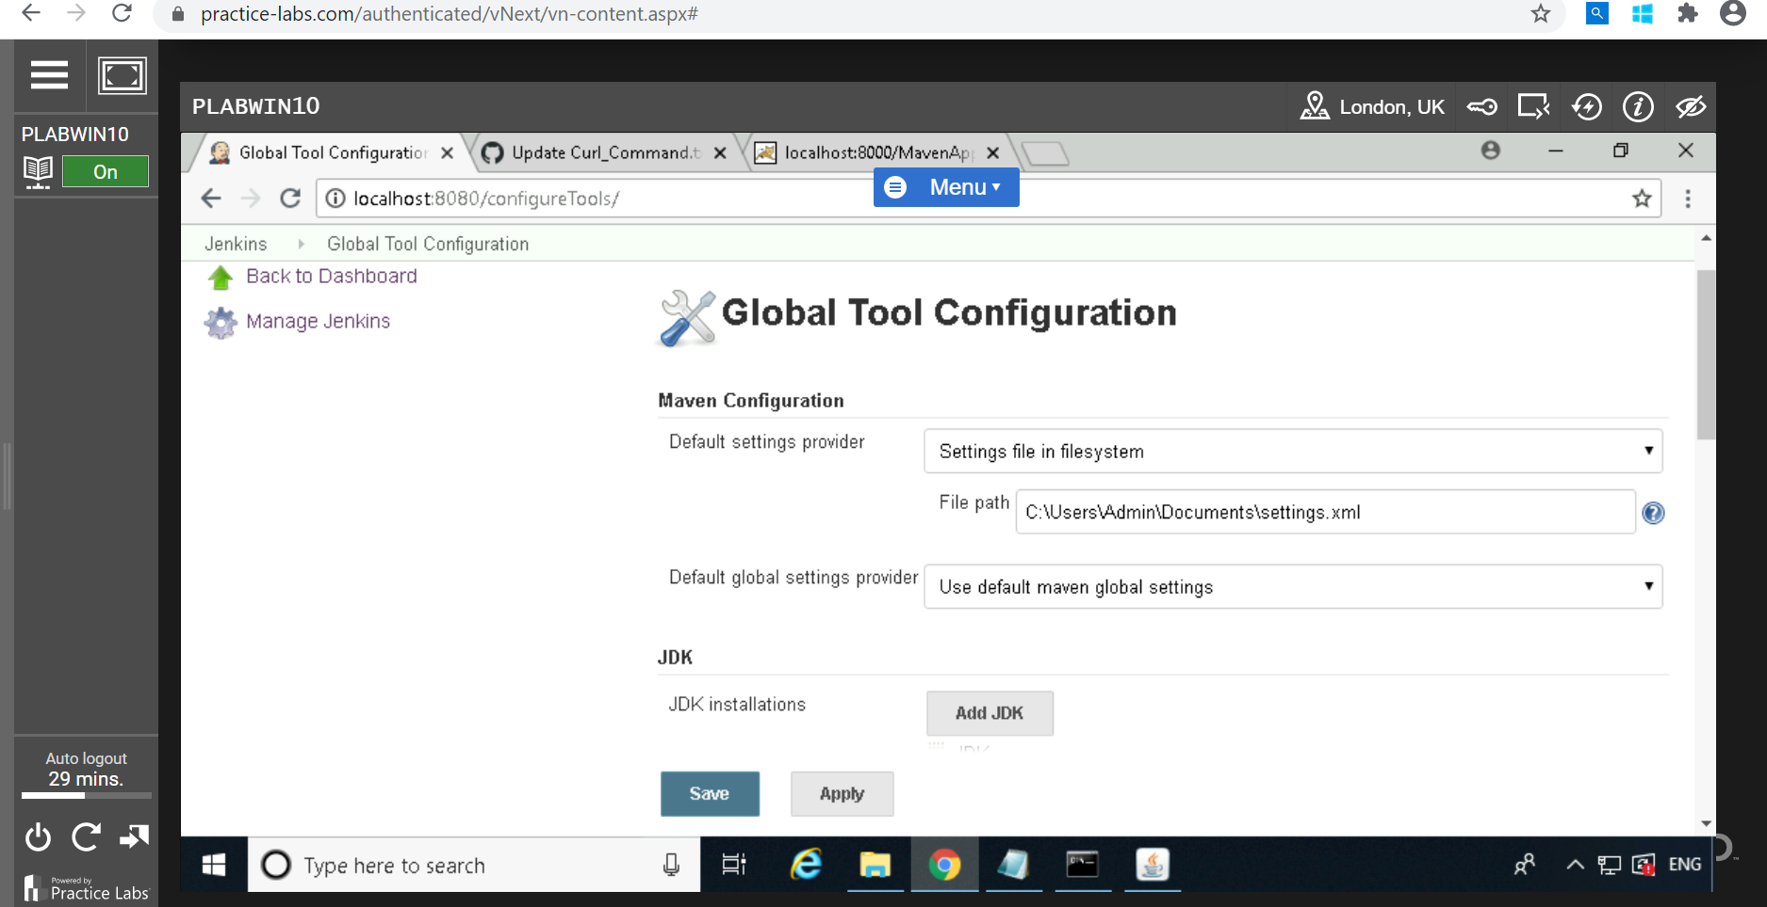

Enter below JDK configuration

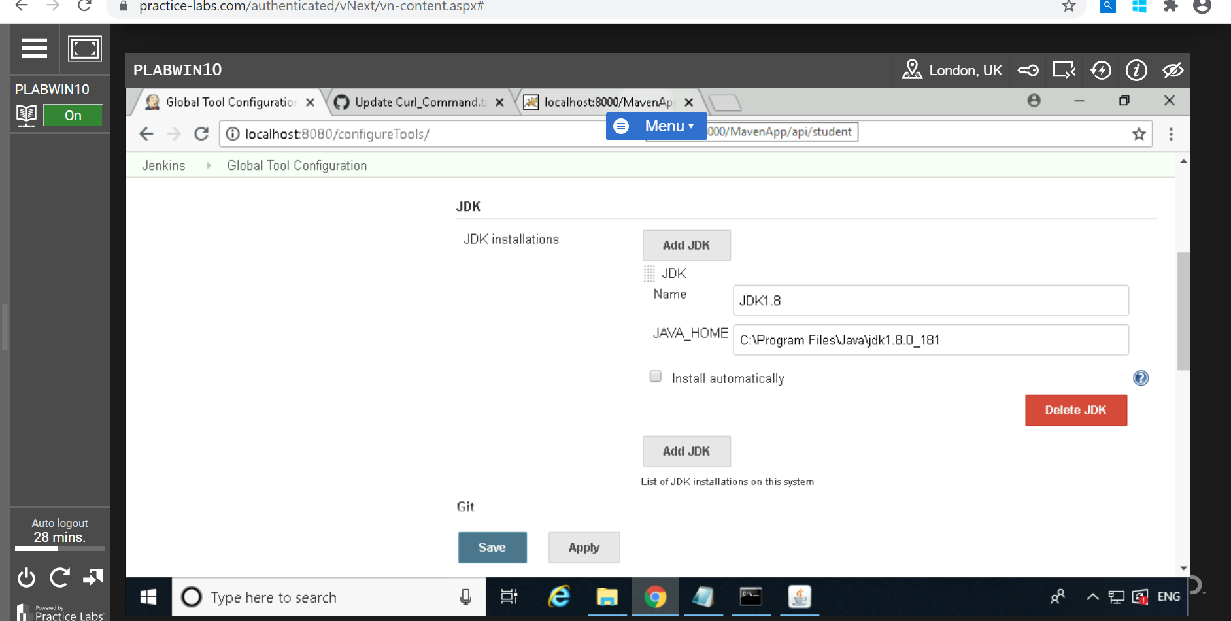

Enter below Maven data

Click on “Save”

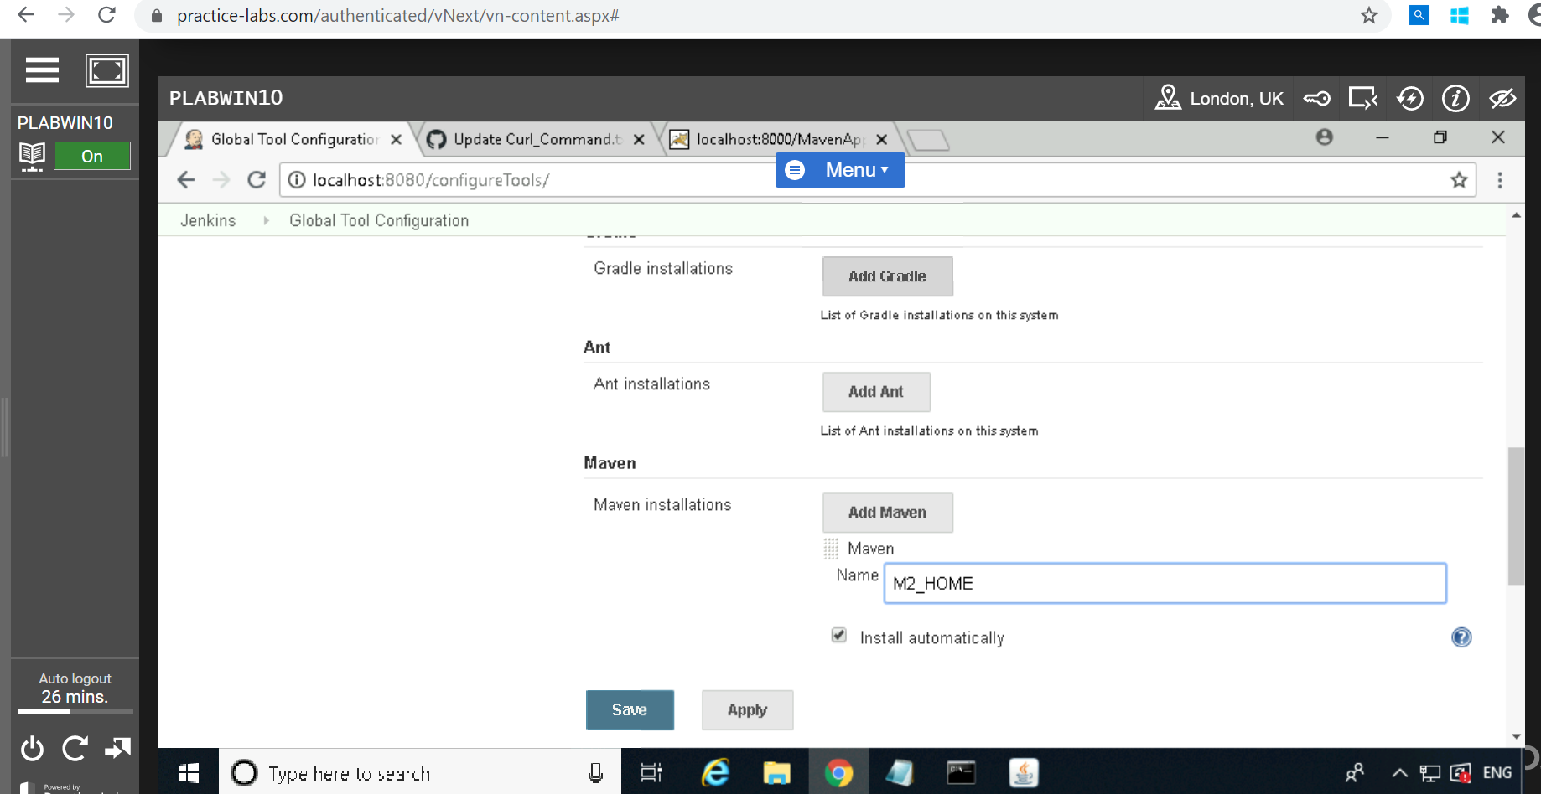

Go to Jenkins homepage and click on “***Pipeline_job***”

Click on “***Configure***”

Click on “***Pipeline***” tab

Enter below “Pipeline script”

Click on “***Save***”

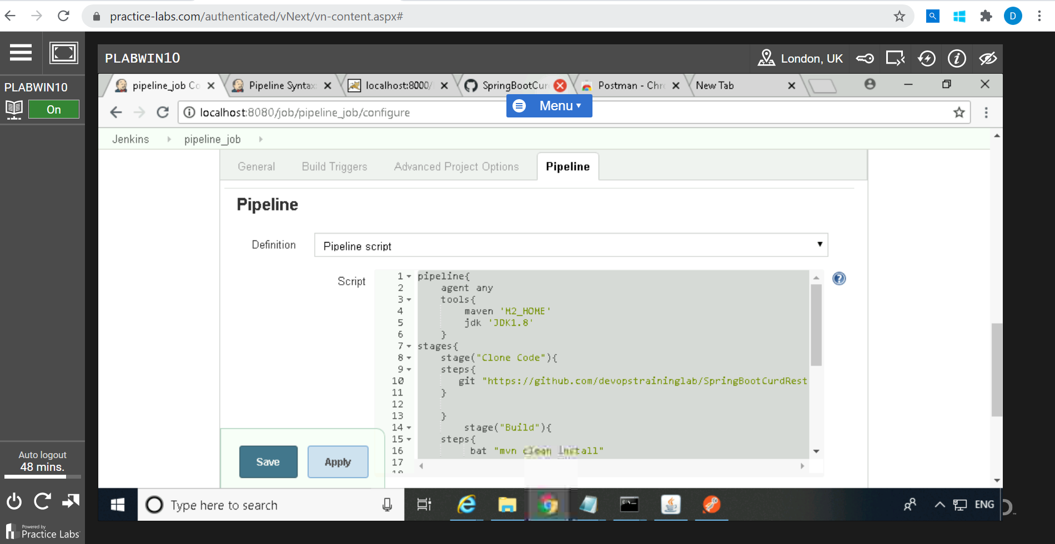

**Pipeline Script**

pipeline{

agent any

tools{

maven 'M2_HOME'

jdk 'JDK1.8'

}

stages{

stage("Clone Code"){

steps{

git "https://github.com/devopstraininglab/SpringBootCurdRestFull.git"

}

}

stage("Build"){

steps{

bat "mvn clean install"

}

}

stage("Test") {

steps{

junit "**/target/surefire-reports/TEST-*.xml"

}

}

stage("Deploy"){

steps{

deploy adapters: [tomcat8(credentialsId: '029802ba-e8af-4e7e-93e0-4a950ca6eea8', path: '', url: 'http://localhost:8000/')], contextPath: 'MavenApp', war: '**/*.war'

}

}

}

}

Click “***Build now***”

After build successfully, below screen will be appear which has all status of pipeline task

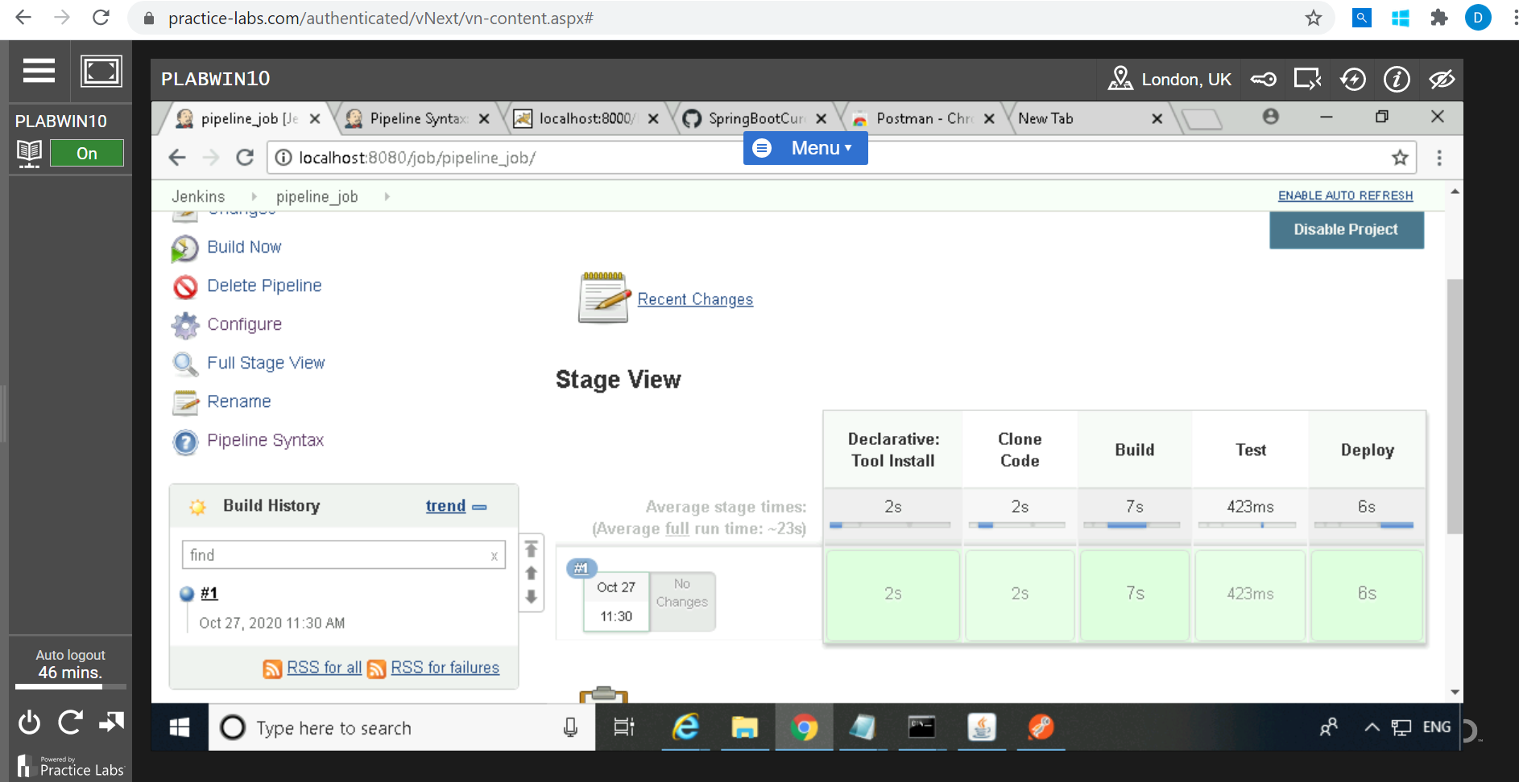

In case of deploy build failure:

Click on “***Pipeline Syntax***” and fill the details as per below:

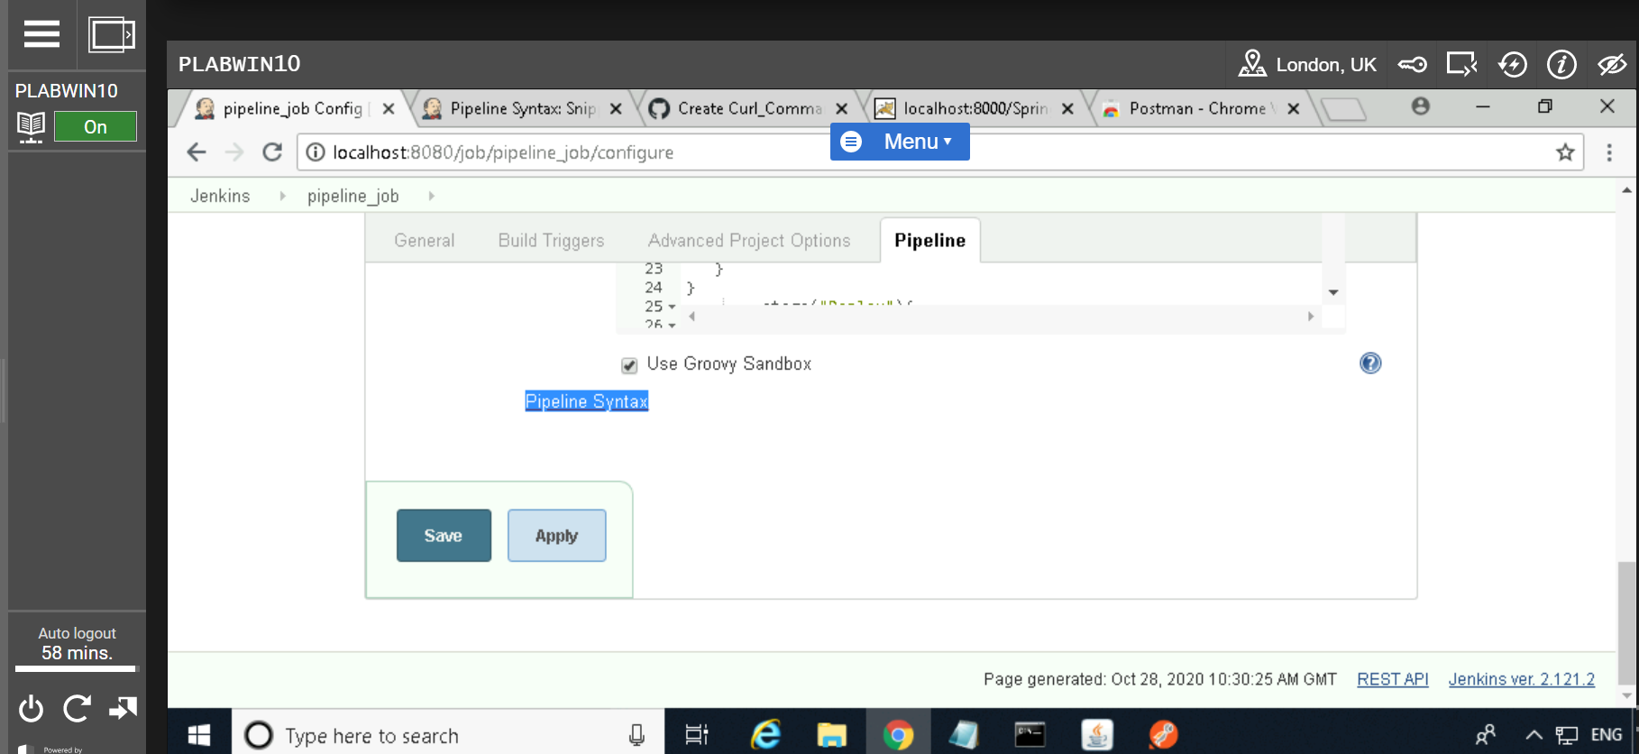

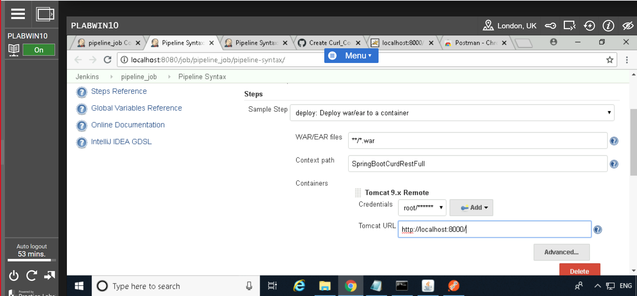

Click on “***Generate Pipeline Script***”

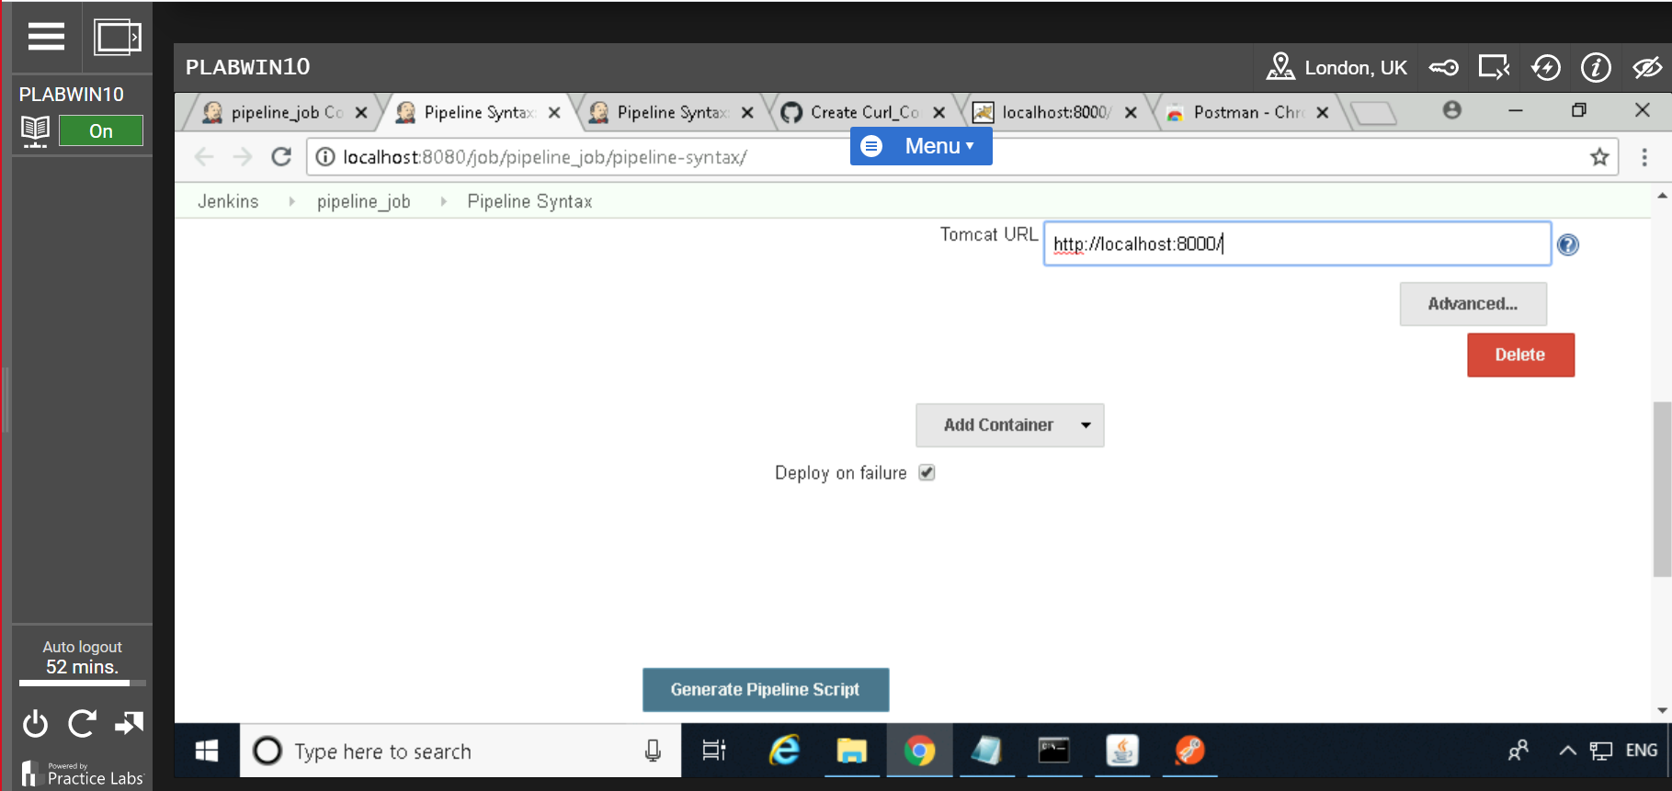

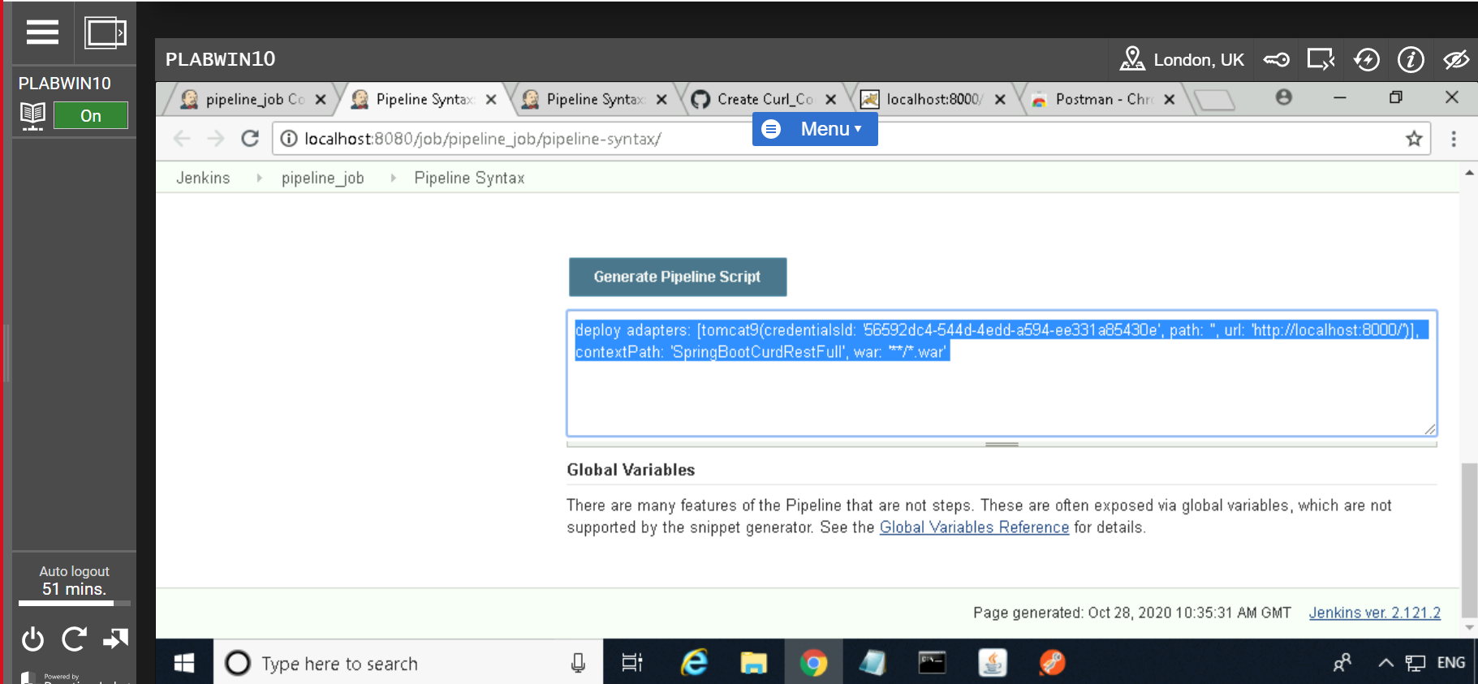

Copy generated deploy adapter script and paste in pipeline scripts.

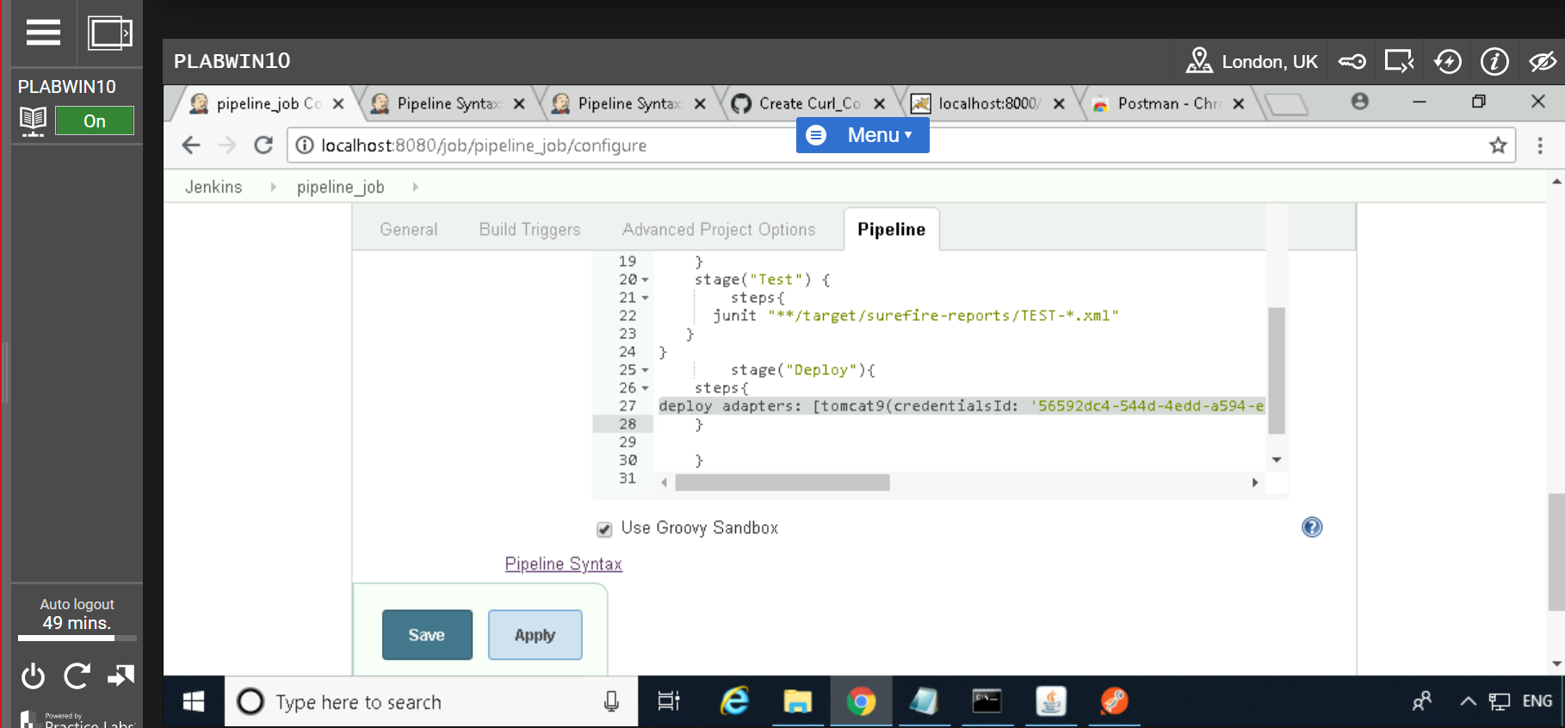

Click on “***Save***”

Click on “***Build now***”

